**Augmented Reality Training Development for a 3D Printer**

Jinhao Pan, Omar Quabili, Thien Vy Tran, Qingboyuan Wang

**Concept of Operations**

April 22nd, 2021

Concept of Operations

for

Augmented Reality Training Development for a 3D Printer

Team 8

Approved by:

Omar Quabili 4/22/2021

Project Leader Date

Andrew Miller 9/1/2020

John Lusher II, P.E. Date

Eric Robles 9/1/2020

T/A Date

**Change Record**

| **Rev.** | **Date** | **Originator** | **Approvals** | **Description** |
| --- | --- | --- | --- | --- |
| 1 | [04/26/2021] | [Team 8] | [Omar Quabili] | Revisions |
| 2 | [04/27/2021] | [Team 8] | [Omar Quabili] | Final |

**Table of Contents**

**Table of Contents** **3**

**List of Figures** **4**

1. **Executive Summary** **5**
2. **Introduction** **5**
   1. Background 6
   2. Overview 6
   3. Referenced Documents and Standards 6
3. **Operating Concept** **6**
   1. Scope 6
   2. Operational Description and Constraints 7
   3. System Description 7
   4. Modes of Operations 8
   5. Users 9
   6. Support 9
4. **Scenario(s)** **9**
   1. Clarifications and Instructions 9
   2. Virtual Try-on 10
   3. In the Healthcare Industry 10
   4. AR Mapping 10
5. **Analysis** **11**
   1. Summary of Proposed Improvements  11
   2. Disadvantages and Limitations 11
   3. Alternatives 12
6. **Reference Documents 12**
7. **Ethical Discussion 12**

**List of Figures**

**Figure 1:** Microsoft Hololens 2 ....………………………………………………………………..**5**

**Figure 2:** Microsoft Hololens 2 component view …..……………………………....……………**8**

**Figure 3:** Machine Learning Training Process …………………………………………………..**9**

**Figure 4:** User interacting with AR models using the Microsoft Hololens 2 ...………………….**9**

# **Executive Summary**

The purpose of our project is to use machine learning and augmented reality to efficiently train a person to use hardware such as a 3D resin printer. Being able to properly utilize this equipment requires an extensive training process in order to avoid damage. If the user were to operate the equipment incorrectly, the machine would need to be reset and cleaned before it is usable again. This long and resource consuming process could be avoided with our project. The aim of our project is to simplify this process and avoid user error. Our solution is to develop an augmented reality aid that will clearly instruct a user on how to operate the 3D resin printer. Doing so, will result in less damage to the hardware and facilitate a more efficient work space.

# **Introduction**

In order to operate a complex instrument requires a long and precise process. First time users often require training that is time consuming and extensive. This process is necessary in order to maintain and keep the instrument functioning properly. If the user were to make the slightest mistake when operating these instruments, it could have high costs to repair, clean, or reset. Our project aims to eliminate and reduce the cost of human error. We plan on doing so by using machine learning and augmented reality to create a virtual training guide. Aiding the user through the process of operating instruments step by step. The goal of our project is to create a precise replication of the instrument and instructions that allow even first time users to operate complex instruments.

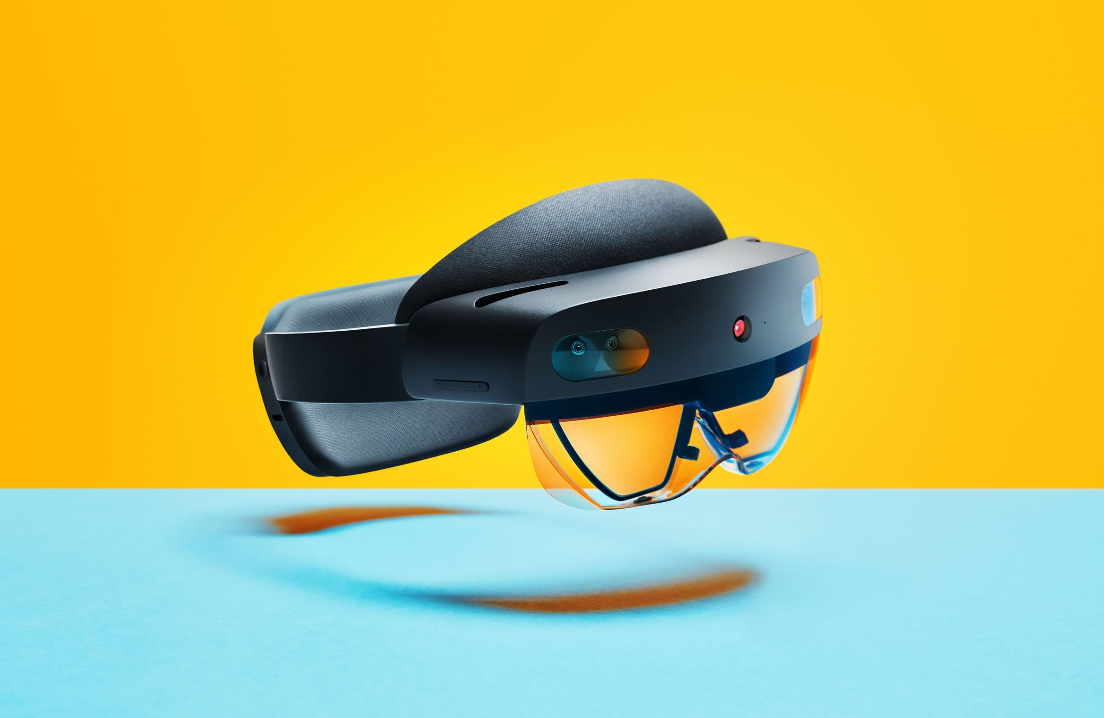

**Figure 1:** Microsoft Hololens 2

## ***Background***

A previous project aimed to achieve the same goals as ours. However, they designed and implemented their augmented reality training using the first Microsoft HoloLens. Our group will be transitioning this to the next generation of this system. The first HoloLens, uses simple tracking with a dot in the middle of the user's field of view. Then the users would use a hand gesture to simulate “clicking on” or making a selection. Our group plans on building upon the last team’s progress by utilizing the Microsoft HoloLens 2. Replacing the original system will enhance the training process for the user because it will clarify and follow the user step by step.

## ***Overview***

The user will be able to use the Microsoft HoloLens 2 to be able to interact with an augmented reality training course. This course will be able to assist any untrained individual on how to operate a 3D resin printer. Once the user puts on the HoloLens, the loaded training course will begin. First, the device will recognize the printer that is being used. Then animations will direct the user through the operation process. Using hand gestures and natural language processing, the user will be able to interact with the training course. The software will recognise the speech or gesture and process animations that correspond to the operation of the instrument. Once the gesture or speech for one step is completed, the next animation will appear, instructing the user on what to next. Doing so will allow the user to have a step by step guide to operating the 3D printer.

* 1. ***Referenced Documents and Standards***
* Unity Deployment for HoloLens
  + <https://docs.microsoft.com/en-us/windows/mixed-reality/develop/unity/unity-development-overview?tabs=arr%2Chl2>
* Microsoft HoloLens 2 Troubleshoot Common Issues
  + <https://docs.microsoft.com/en-us/hololens/hololens-troubleshooting>
* Microsoft HoloLens 2 Application Management Overview
  + <https://docs.microsoft.com/en-us/hololens/app-deploy-overview>
* Microsoft HoloLens 2 Basic Usage Overview
  + <https://docs.microsoft.com/en-us/hololens/hololens2-setup>

# **Operating Concept**

# ***Scope***

The specific goal for this project is to be able to teach an individual, with no prior training, how to use a complex instrument or an elaborate skill. To prove and test this concept, this project will utilize machine learning and augmented reality to assist an untrained individual on the operation of a 3D printer. The tasks assigned to this team has been split into four different subsystems:

-Machine Learning Utility

-Modeling/Animation

-UI through NLP or Hand Gestures

-Unity 3D Environment

The development of each subsystem will be thoroughly documented and all software will be hosted on a github accessible to all team members.

## ***Operational Description and Constraints***

This project is meant to serve as a proof of concept and as a gateway to numerous possible applications. The augmented reality training method has the ability to train a vast collection of disciplines and can be effectively applied to many industries. The Microsoft HoloLens 2 only requires an open space and the subject of training physically in front of the user. The 3D augmented reality environment will be designed through the Unity Game Engine. Animations and modeling will be done in Blender 2.90 which is a computer animation and modeling software. The system must adhere to the following constraints:

* The machine learning operation must be able to identify the 3D printer subject.
* An easy to navigate user interface must be developed. This will be implemented into the overall 3D environment.
* Models and animations must be designed. They must also be stitched correctly to the 3D AR environment.
* All software developed must be compatible with the Microsoft HoloLens 2. Software from the previous team must be translated from the first Microsoft HoloLens to be compatible with the new Microsoft HoloLens 2.
* The four subsystems mentioned in section 3.1 must be compatible with each other to be robust and operable.

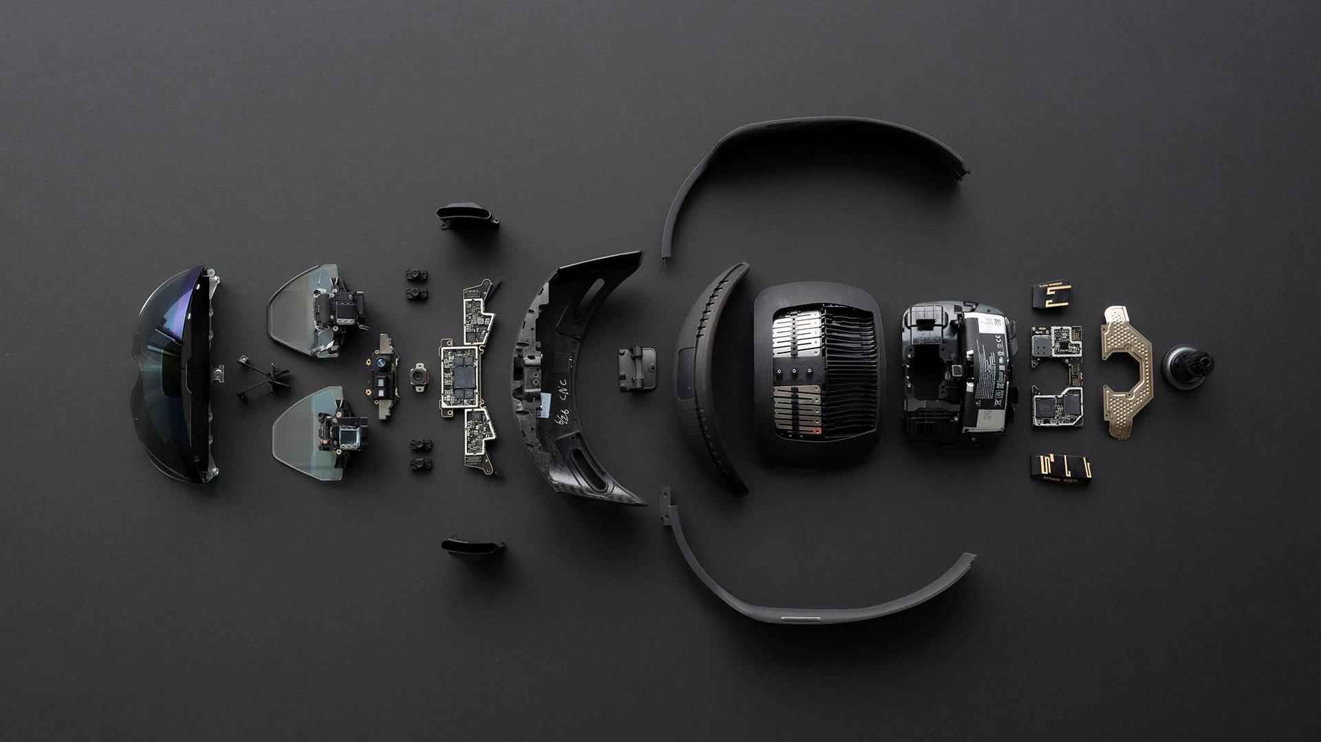

**Figure 2:** Microsoft HoloLens 2 component view

## ***System Description***

* Machine Learning Utility: This subsystem must be trained to quickly identify the 3D printer subject. The utility will be able to recognize the printer from various distances, angles, and lighting conditions. The utility must also be able to work in parallel with the 3D environment. The MLU (Machine Learning Utility) will be deployed onto the camera of the laptop with the completed Unity project or optimally on the Microsoft HoloLens 2.
* Modeling/Animation: Modeling and animation will be done with the Unity Engine design suite and Blender 2.90. The models will be correctly stitched to the environment. Animations will be correctly triggered by certain actions and human interaction.
* UI through Natural Language Processing or Hand Gestures: A user interface will be made as the primary bridge of contact between the human user and the augmented reality environment. There will be two modes of interaction that the user can make with the environment: Complex hand gestures and Natural Language Processing. This allows the user to interact with the training course with both speech and hand movement.
* Unity 3D environment: The Unity 3D environment will serve as the backdrop for the training interface. The 3D environment will work in conjunction with the machine learning utility to set up an open space as the foundation for the models and the user interface.

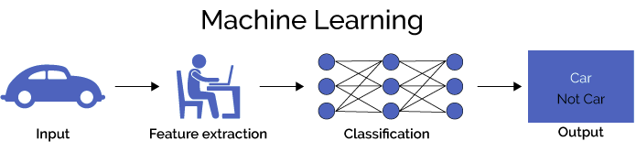

**Figure 3:** Machine Learning Training Process

## ***Modes of Operations***

The Augmented Reality Training Development for a 3D Printer will only have one mode of operation which is ON. Once the Microsoft Hololens 2 is powered on, the augmented reality training will be initialized once the user starts the application. From this point forward, the training program will guide the user without any mode of interaction. This process is meant to be simple and automatic to the degree which any untrained individual will be able to operate.

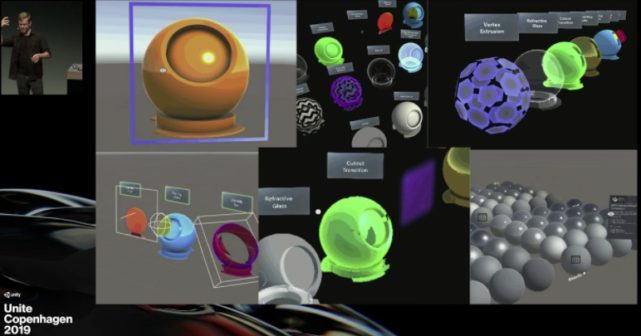

**Figure 4:** User interacting with AR models using the Microsoft HoloLens 2

## ***Users***

The Augmented Reality Training is designed to be able to teach any untrained individual the operation of a complex instrument or the execution of an elaborate skill. Little technical experience is required to start up the AR program on the Microsoft HoloLens 2. This allows the technology to be implemented into other sectors such as the military, medicine, of power plants. The method allows for faster training which will save companies time and money when compared to the typical onboarding process.

## ***Support***

Support for the Augmented Reality Training Development for a 3D Printer will be provided as a detailed user instruction manual. The manual will contain deep information of the operation of the Microsoft HoloLens 2, maintenance of the headset, and instructions on how to load training programs from third party sources. Documentation for the Microsoft HoloLens 2 will also be provided. The user manual will include the 3D Printer training course as an example of the operation of the system.

# **Scenario(s)**

# ***Clarifications and Instructions***

In case some instruments are very hard to use, people are tired of looking at the actual paper instructions, and the cost of making mistakes may be very high. For example, the 3D printer is not easy to operate and implement at the first few times, and if people make some mistakes, the materials are very expensive to waste. The HoloLens can generate the AR 3D printer, which will be the exact same as the real one but virtually. People can follow the instructions or demo videos to operate the machine virtually and to get along with how to use the 3D printer. Thus, people can learn and know how to operate certain machines without the fear of damaging materials or wasting time with improper operations. The AR implementation of HoloLens can help people to deal with this dilemma for offering useful clarifications and instructions in the virtual world.

## ***Virtual Try-on***

In this case, it is very useful for people who would like to go shopping online, but they cannot try the product in reality. For example, if people want to buy one pair of Nike shoes, they do not know the exact size, but they can use HoloLens to see if the shoes can perfectly fit your foot. Thus, people do not need to go to the actual store, and the most annoying feature of shopping online can be fixed easily. This method can apply to a lot of products in real life, such as buying a new watch to see if this can fit you appropriately. The AR technology based on HoloLens can bring a more convenient lifestyle. The Microsoft HoloLens 2 can boost the shopping experience and make things simpler.

## ***In the Healthcare Industry***

The most important implementation of Microsoft HoloLens 2 is that it can create a virtual world to let the doctor do any medical operations or how to implement surgeries to interact with patients. In this helpful AR scenario, novice doctors can use HoloLens to simulate how to do certain surgeries, so they can learn from their mistakes without paying extreme prices, such as taking people’s lives. In this situation, all doctors can plan procedures of doing surgeries. The Microsoft HoloLens 2 can boost the healthcare industry and may help to raise the success rate of doing surgeries and to build some medical models to solve some diseases.

## ***AR Mapping***

How can you find everything you want and go everywhere you want in an airport with 17207 acres? The Microsoft HoloLens 2 can offer a feature such as a map, guiding people to wherever they want to go. The AR map can be extremely useful in one specific building, like how to find a parking lot, how to find a specific store, how to find a specific restaurant, and how to find the closest restroom. Wearing the HoloLens, people will hardly ever get lost. People can confidently cross any terminals and go to any locations they want. No matter if people are new to the airport or are very familiar with the airport, they all can gain different benefits from the AR technology.

# **Analysis**

## ***Summary of Proposed Improvements***

The biggest improvement to this reinforced system would be to give the novice user a better, or an instant, understanding of how to use a complex system (A 3D printer for this project). The reason would be that when dealing with the old system which was implemented on Microsoft Hololens 1, the functionalities are pretty much restricted in a way that the camera and the application can not be used at the same time. Also, the previous version did not have Natural Language Processing functionalities which allows a user to command the system using his/her voices. In addition, the view for Microsoft Hololens 1 was a lot smaller than the second generation ones. A bigger view would not only give the user a better picture of the operation procedures but also enabling us, as developers, to add more functionalities up there on the headset.

## ***Disadvantages and Limitations***

One big limitation of this headset, or system, would be that it would only capture the HoloLens images at a certain point. For instance, a user might only be able to use the system when he/she stands at some designated positions. This greatly limited the accessibility of the whole system. Another technical disadvantage would be that the system needs to be working when the 3D printer, or other complex systems, is physically present in front of the user. It could not have the whole system, take the 3D printer as an example, being simulated on an empty desk. The purpose of the application is to teach the user how to operate a physical instrument rather than watching a hologram of its operation. This disadvantage also restricted the accessibilities of this headset since the users will not be able to use it to virtually learn how to use a complex equipment without the equipment itself being physically there.

## ***Alternatives***

Instead of using this Microsoft Hololens 2 headset we are about to develop, the institutions or companies could still get their students or employees trained by: 1. Provide them the user manual of the equipment and let them read through every single line of it. 2. Hire or have the experienced technicians to teach the students or employees hand-by-hand. 3. Have students or employees learn how to use the equipment by themselves from whatever sources they might have access to. For the first proposed alternative approach, the advantage would be that the user manual does have every detail included and he/she will be able to properly operate the equipment if he/she studies it well enough. However, the problem here is that for some large equipment, especially for the ones used for research labs, the user manual is often hundreds of pages long with very small font size. Even if a user could read it thoroughly, there is still a very high chance of making mistakes and the time he spent on reading this long manual could have been used for other works. For the second alternative, the advantage is obvious that people would definitely learn better with an instructor stand with him/her. But for most companies and universities, the expenses for this instructing process would be too high to implement. Having a single headset acting as the instructor 24/7 with a very low cost is obviously a better option. The drawbacks for the third alternative are obvious, letting people learn by themselves not only increases the uncertainty of the learning outcome but could also lead to some accidents if not learned well. To sum up, using this Microsoft Hololens 2 headset to teach a novice user how to use a complex system or equipment is obviously a good choice.

1. **Reference Documents**

| **Revision/Release Date** | **Document Title** |
| --- | --- |
| 09/17/2019 | Microsoft HoloLens 2 |
| 09/14/2020 | Visual Studio 2019 version 16.8 documentation |
| 09/08/2020 | Unity User Manual (2019.4 LTS) |
| 08/31/2020 | Blender 2.90 |

## 

1. **Ethical Discussion**

For our project, there was an ethical consideration we needed to address. We had to consider the ethical use of the previous team’s contribution to this project. We chose to navigate this issue with the guidance of our sponsor and only used and improved the code that was approved by them. We also reference and give credit to the previous team where it was applicable.

Augmented Reality Training Development for a 3D Printer

Omar Quabili, Thien Vy Tran, Jinhao Pan, Qingboyuan Wang

**Functional System Requirements**

Functional System Requirements

For

Augmented Reality Training Development for a 3D Printer

Approved by:

Omar Quabili 4/22/2021

Project Leader Date

Andrew Miller 11/24/2020

John Lusher, P.E. Date

Eric Robles 11/24/2020

T/A Date

**Change Record**

| **Rev.** | **Date** | **Originator** | **Approvals** | **Description** |
| --- | --- | --- | --- | --- |
| **-** | [04/26/2021] | [Team 8] | [Omar Quabili] | Revisions |

**Table of Contents**

**Table of Contents 16**

**List of Figures 17**

**List of Tables 17**

1. **Introduction** **18**
   1. Purpose and Scope 18
   2. Responsibility and Change Authority 18
2. **Applicable and Reference Documents** **19**
   1. Referenced Documents 19
   2. Order of Precedence 19
3. **Requirements** **20**
   1. System Definition 20
   2. Characteristics 20
      1. Functional / Performance Requirements 21
         1. The Efficiency of Use 21
         2. The Minimization of Processing Time 21
      2. Software Requirements 21
         1. Operating Systems 21
         2. Animation Requirements in 3D Environments 21
         3. Natural Language Processing 21
         4. Machine Learning 22
4. **Support Requirements** **22**
5. **Validation and Execution Plan** **22**

5.1. Execution Plan 22

5.2. Validation Plan 24

**Appendix A: Acronyms and Abbreviations** **25**

**Appendix B: Definition of Terms** **25**

**Appendix C: Animation Requirements 25**

**Appendix D: Questions Handled by NPL 25**

**List of Figures**

**Figure 1:** Conceptual Image ...………………………………………………………………...**18**

**Figure 2:** Block Diagram of System ………………......……………………………………….**20**

# 

# **Introduction**

# ***Purpose and Scope***

# Extensive training is needed to be able to operate instruments such as the FormLabs Form 3 3D printer. If the user were to make a mistake during operation, the cost and time of resetting the machine could be detrimental to a productive work environment. Our project will use voice recognition and gesture inputs, machine learning, Unity 3D Environment, and Blender 3D Animation Suite to provide detailed instructions for users. Using the Microsoft HoloLens 2, we shall design and project an augmented reality space for the user. This hardware will then use natural language processing and machine learning to recognize the location of the 3D printer and speech from the user. With Unity 3D Environment and Blender 3D Animation Suite, the given inputs will display and output visuals that will guide a first time user through the operation of the FormLabs Form 3 3D printer. Our project aims to minimize user error and facilitate a productive work environment, while also lowering the cost due to misuse of the instrument.

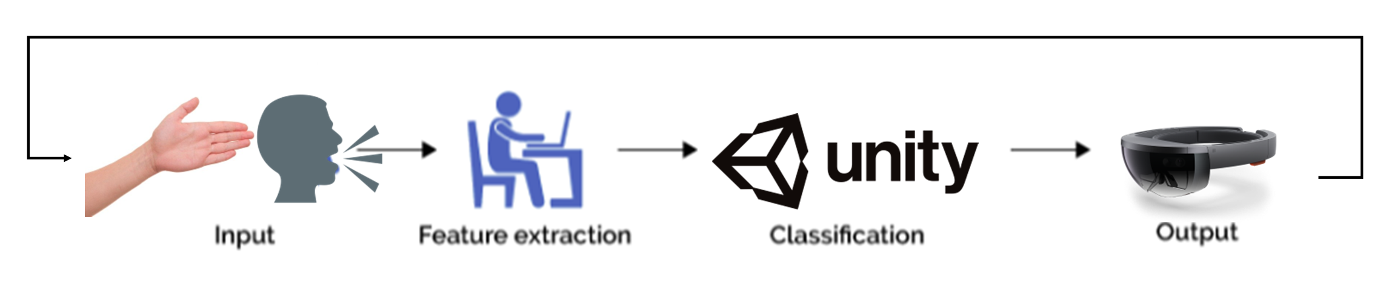

**Figure 1. Conceptual Image**

## ***Responsibility and Change Authority***

The team leader, Omar Quabili, has the responsibility for ensuring all specifications and requirements are met. Any changes are to be approved by the team leader and project sponsor, Andrew Miller.

# **Applicable and Reference Documents**

# ***Purpose and Scope***

| **Revision/Release Date** | **Document Title** |
| --- | --- |
| 09/17/2019 | Microsoft HoloLens 2 |
| 09/14/2020 | Visual Studio 2019 version 16.8 documentation |
| 09/08/2020 | Unity User Manual (2019.4 LTS) |
| 08/31/2020 | Blender 2.90 |

## ***2.2. Order of Precedence***

In the event of a conflict between the text of this specification and an applicable document cited herein, the text of this specification takes precedence without any exceptions.

All specifications, standards, exhibits, drawings or other documents that are invoked as “applicable” in this specification are incorporated as cited. All documents that are referred to within an applicable report are considered to be for guidance and information only, except ICDs that have their relevant documents considered to be incorporated as cited.

# **Requirements**

## ***3.1. System Definition***

## 

**Figure 2. Block Diagram of System**

HoloLens 2 offers the most comfortable mixed reality experience, which is enhanced by the reliability, security, and scalability of cloud and AI services. In this project, HoloLens will mainly focus on the FormLabs Form 3 3D printer. HoloLens 2 implementation can be divided into four separate subsystems: Natural Language Processing (NLP) and gesture inputs, machine learning (mainly computer vision), Unity 3D Environment, and Animation.

Users can use HoloLens 2 as the guide to use and get familiar with 3D printers with basic instructions, which they can operate 3D printers by themselves by following the tutorials. Users can make minute changes to the print model after the user progresses through setting up the FormLabs 3 3D Printer.

## ***3.2. Characteristics***

### ***3.2.1. Functional / Performance Requirements***

#### ***3.2.1.1. The Efficiency of Use***

The Microsoft HoloLens 2 (MHL) must allow the user to access and manipulate 3D object files (.obj) with natural ease and minimal interactions with the MHL. As a result, all programming and user interface must be done on the MHL unit itself. This means that the user will have no need to access external sources (e.g. other softwares) and everything will be done based on user inputs within this Augmented Reality environment. This project will be a success if and only if the final design of the AR environment is significantly easier to use than traditional teaching styles.

#### ***3.2.1.2. The Minimization of Processing Time***

The optimal or ideal waiting time for a user waiting for the commands to run is usually less than three seconds. However, slicing and preparing to print can take a large amount of time because of the way .obj files were formed. Greedy algorithms, which have an exponentially grown run time complexity, further increases the wait time until user command can be received. Consequently, these algorithms have to be excluded from this constraint which is inefficient overall.

### ***3.2.2. Software Requirements***

#### ***3.2.2.1. Operating Systems***

The required operating system has to be Windows 10 in order to be compatible with Microsoft HoloLens 2. In addition, the FormLabs software has to be run on another computer nearby. And in order to get them together, everything will be compiled through the Unity development environment. To accomplish this task, Visual Studio 2019 will be utilized alongside the latest stable release of the Unity 3D development environment.

#### ***3.2.2.2 Animation Requirements in 3D Environments***

For the animations, all should be operating in a 30 fps manner, which is the national television standard. To streamline the end experience for the user, the animations must include the parameters mentioned in Appendix C.

In addition to the conditions mentioned, all models and animations must be properly stitched to their environment to prevent the user from observing any jarring or visual discrepancies.

#### ***3.2.2.3 Natural Language Processing***

The training process of voice and gesture input should function at least 85% accuracy in order to fully implement HoloLens 2 and avoid misunderstanding. Thus, there should be sufficient enough voice commands to modify and print processes. Users should be asked a lot of specific questions, thus users can comprehensively understand how to use a 3D printer. Some example questions and answers are listed in Appendix D.

***3.2.2.4 Computer Vision & Machine Learning***

Decided to implement Vuforia, an Unity engine, to identify the 3D printer under an Unity environment. The input will be a 3D object file, such as .STL or .OBJ, and the vuforia cloud will output the rating of the file input while implementing the Machine Learning algorithms. Once successfully implemented, the camera will be able to recognize the 3D printer within approximately 70 degree of angle.

# **Support Requirements**

To ensure that the user’s data does not get lost or damaged due to the device shutting down, the Microsoft HoloLens 2 needs to be at least charged to some extent. It also requires that the 3D printer is not completely or largely obscured by other objects. If so, the HoloLens 2 may not be able to recognize the printer. The user must also ensure that there is no or very little background noise in the area of operation to allow the voice to be input to NLP for processing and to distinguish user commands from background noise. Finally, users are expected to have access to a Microsoft HoloLens 2 and a FormLabs Form 3 3D printer.

1. **Validation and Execution Plan**
   1. ***Execution Plan***

For the effectiveness of this project, we have break down the whole design into 4 subsystems as shown below:

***Machine Learning (Computer Vision):*** The purpose of this subsystem is to provide the functionality for automatic calibration and to track the printer’s location so that the animations will be pinned to the correct locations.

***Natural Language Processing (NLP):*** As to the limitations of HoloLens 2, we needed an extra approach so that the users will be able to instruct the system. And using voice input was the most efficient way to accomplish this.

***Unity Modeling (Preparation of 3D Objects):*** In order to have better communications between the application and the 3D printer, we will need to have the object preparation system, which sends data received from the user’s voice input to the PreForm software to operate on another computer which then sends data directly to the 3D printer.

***Animation and Modeling:*** We will be developing an accurate 3D model for the FormLabs Form 3 printer as well as all associated animations involved with it. These animations will guide the user through the operations of the printer.

Once each subsystem had been designed to completion, they would be integrated using pre-planned structures within the Unity platform of the natural language processing subsystem. Once integration was complete, the system would be available for testing and tweaking to better suit user needs.

|  | February 2, 2021 | February 16, 2021 | February 28, 2021 | March 3, 2021 | March 8, 2021 | April 3, 2021 |
| --- | --- | --- | --- | --- | --- | --- |
| Integrate the animation/modelling subsystem into the 3D environment. | Completed |  |  |  |  |  |
| Integrate the NLP subsystem into the 3D environment. |  | Completed |  |  |  |  |
| Integrate the CV/ML subsystem to be able to recognize the 3D printer. |  |  | Completed |  |  |  |
| Testing and debugging CV/ML and Animations and Modelling. |  |  |  | Completed |  |  |
| Testing and debugging NLP. |  |  |  |  | Completed |  |
| Add finishing touches to finalize the project. |  |  |  |  |  | Completed |

* 1. ***Validation Plan***

|  | **February 2nd** | **February 16th** | **February 28th** | **March 3rd** | **March 8th** | **April 3rd** |
| --- | --- | --- | --- | --- | --- | --- |
| Validation Plan | Ensure the user can directly control the animations of the model. | Testing each command, can achieve 60% accuracy | Testing to achieve 80% accuracy and fully functional | Testing to achieve 90% accuracy and fully functional. | Testing each command, can achieve 80% accuracy | NLP for at least 90% accuracy for commands |

# **Appendix A: Acronyms and Abbreviations**

NLP Natural Language Processing

CV Computer Vision

MHL Microsoft HoloLens

CV Computer Vision

Unity 3D Environment (Game Engine)

PreForm 3D printer application

GUI Graphical User Interface

# **Appendix B: Definition of Terms**

.obj 3D Object File

Unity Game Engine

Greedy Algorithm Processing through each possible case and very inefficient with timing

**Appendix C: Animation Requirements**

* A view of the 3D printer itself.
* Step by step Animations of the user instructions.
* Cleaning of printing platform.
* Inserting of necessary components needed to operate the printer.
* Steps to insert and open printer cartridge.

**Appendix D: Questions Handled by NLP**

* What is raft type?
  + It will print raft type
* What is density?
  + It will print density
* What is a touchpoint size?
  + It will give touchpoint size
* What is layer thickness?
  + It will give a raft label
* What is height?
  + It will give x, y and z scale
* What is scale?
  + It will print overall scale
* How do I know my part is ready to go?
  + It will auto orient project

Augmented Reality Training Development for a 3D Printer

Omar Quabili, Thien Vy Tran, Jinhao Pan, Qingboyuan Wang

**Interface Control Document**

Interface Control Document

For

Augmented Reality Training Development for a 3D Printer

Approved by:

Omar Quabili 4/22/2021

Project Leader Date

Andrew Miller__________11/24/2020

John Lusher II, P.E. Date

Eric Robles 11/24/2020

T/A Date

**Change Record**

| **Rev.** | **Date** | **Originator** | **Approvals** | **Description** |
| --- | --- | --- | --- | --- |
| **-** | [04/26/2021] | [Team 8] | [Omar Quabili] | Revisions |

**Table of Contents**

**Table of Contents 29**

1. [**Overview**](https://docs.google.com/document/d/1kOD7QlfxUWpu_osNgRvUPzzjd65tmAB1PCs89QSvpfo/edit#heading=h.35tzckigkw7c) **30**
2. [**References and Definitions**](https://docs.google.com/document/d/1kOD7QlfxUWpu_osNgRvUPzzjd65tmAB1PCs89QSvpfo/edit#heading=h.4j07e1ed273u) **31**

2.1 [References](https://docs.google.com/document/d/1kOD7QlfxUWpu_osNgRvUPzzjd65tmAB1PCs89QSvpfo/edit#heading=h.11uqhm7t40ro) 31

2.2 [Definitions](https://docs.google.com/document/d/1kOD7QlfxUWpu_osNgRvUPzzjd65tmAB1PCs89QSvpfo/edit#heading=h.pqmu70807zlw) 31

1. [**Physical Interface**](https://docs.google.com/document/d/1kOD7QlfxUWpu_osNgRvUPzzjd65tmAB1PCs89QSvpfo/edit#heading=h.tyjcwt) **32**

3.1 [Weight](https://docs.google.com/document/d/1kOD7QlfxUWpu_osNgRvUPzzjd65tmAB1PCs89QSvpfo/edit#heading=h.hx640rz4d533) 32

3.1.1 HoloLens 2 32

3.1.2 FormLabs Form 3 32

3.2 [Dimensions](https://docs.google.com/document/d/1kOD7QlfxUWpu_osNgRvUPzzjd65tmAB1PCs89QSvpfo/edit#heading=h.rmscipfnc92q) 32

3.2.1 HoloLens 2 32

3.2.2 FormLabs Form 3 32

3.3 [Mounting Locations](https://docs.google.com/document/d/1kOD7QlfxUWpu_osNgRvUPzzjd65tmAB1PCs89QSvpfo/edit#heading=h.xs0zdem6r1jl) 32

1. [**Electrical Interface**](https://docs.google.com/document/d/1kOD7QlfxUWpu_osNgRvUPzzjd65tmAB1PCs89QSvpfo/edit#heading=h.uyvl9ll0tnqm) **33**

4.1 [Primary Input Power](https://docs.google.com/document/d/1kOD7QlfxUWpu_osNgRvUPzzjd65tmAB1PCs89QSvpfo/edit#heading=h.cx3wsvhwrpiq) 33

4.2 [Video Interfaces](https://docs.google.com/document/d/1kOD7QlfxUWpu_osNgRvUPzzjd65tmAB1PCs89QSvpfo/edit#heading=h.ifzibm4qo2hq) 33

4.3 [User Control Interface](https://docs.google.com/document/d/1kOD7QlfxUWpu_osNgRvUPzzjd65tmAB1PCs89QSvpfo/edit#heading=h.cgcch1vy5mw5) 33

1. [**Communications / Device Interface Protocols**](https://docs.google.com/document/d/1kOD7QlfxUWpu_osNgRvUPzzjd65tmAB1PCs89QSvpfo/edit#heading=h.7lgs43wkpy84) **34**

5.1 [Wireless Communications (WiFi)](https://docs.google.com/document/d/1kOD7QlfxUWpu_osNgRvUPzzjd65tmAB1PCs89QSvpfo/edit#heading=h.hnlsop1g1wyv) 34

5.2 [Host Device](https://docs.google.com/document/d/1kOD7QlfxUWpu_osNgRvUPzzjd65tmAB1PCs89QSvpfo/edit#heading=h.33t4u1konqy9) 34

5.3 [Video Interface](https://docs.google.com/document/d/1kOD7QlfxUWpu_osNgRvUPzzjd65tmAB1PCs89QSvpfo/edit#heading=h.yn8i4lin1icf) 34

1. **Software Interface 34**

6.1 HoloLens 2 to Unity 34

6.2 HoloLens 2 to Computer 34

6.3 HoloLens to PreForm Software 35

# **Overview**

This document will detail the specifications of the HoloLens 2 and FormLabs Form 3 3D printer. These specifications will include the physical dimensions and weight of the instruments. A summary of the electrical and communication specifications will also be provided along with a description of the software interfaces needed to provide a functional augmented reality space. This report will also include software methods used to ensure complete functionality of the HoloLens 2.

# **References and Definitions**

## **References**

1. PDF: HoloLens 2 Tech Specs: 9/16/2020:

<https://www.bechtle.com/shop/medias/5db2b2114c2f850c73f2c3b8.pdf?context=bWFzdGVyfHJvb3R8ODg4Mzl8YXBwbGljYXRpb24vcGRmfGg4My9oMzYvMTA5Mjc3NjQ2MDI5MTAucGRmfDZjYWU3MGY2OGVmYWQyN2I2NTUwMzExYzllMTcyMGIwN2Y3ZWJlYWI0MWE2ZTZmYmQ2ZDU2MWNkNDRkMWMxZDg>

1. Lang, B. (2019, February 24). HoloLens 2 Specs Reveal 2–3 Hour 'Active' Battery Life, Optional Top Strap, & More. Retrieved September 16, 2020, from <https://www.roadtovr.com/hololens-2-specs-resolution-field-of-view-battery-life/>
2. FormLabs Form 3 Manual:

<https://media.formlabs.com/m/5a3f3cadc639b857/original/-ENUS-Form-3-Manual.pdf>

## **Definitions**

NLP Natural Language Processing

CV Computer Vision

Unity 3D Environment (Game Engine)

PreForm 3D printer application

GUI Graphical User Interface

.obj 3D Object File

Unity Game Engine

Greedy Algorithm Processing through each possible case and very inefficient with timing

## 

# **Physical Interface**

## **Weight**

* + 1. ***HoloLens 2***

The HoloLens 2 has an approximate weight of 1.25lbs.

* + 1. ***FormLabs Form 3 (3D printer)***

The FormLabs Form 3 has an approximate weight of 37.9lbs.

## **Dimensions**

### ***HoloLens 2***

The HoloLens 2 fits over glasses and is fully adjustable, allowing the user to adjust the fit to their preference.

* + 1. ***FormLabs Form 3 (3D printer)***

The FormLabs Form 3 printer has a height of 20.9”, a width of 15.9”, and a depth of 14.8”.

## ***Mounting Locations***

The HoloLens 2 will be mounted on the head of the user, with the sensors fitted over the eyes. The FormLabs Form 3 can be mounted on top of a flat surface with a height of 30.5”, a width of 15.5”, and a depth of 21” to allow for convenient access. The printer must also have clear access to a power source.

# **Electrical Interface**

## ***Primary Input Power***

The HoloLens 2 uses a rechargeable battery that lasts 2-3 hours of active use and about 2 weeks during standby. The battery can be recharged using a USB Type-C cable.

## ***Video Interfaces***

During the development phase of the project, both the video interface of the HoloLens and the video output in the development environment will be used by the project team only. Outside of development, the user will only have access to the HoloLens’ video interface.

## ***User Control Interface***

The user will be able to interact with the HoloLens using two different methods: hand gesture inputs and speech recognition. The hand gesture detection will be done by the camera on the unit while the voice commands will be processed by the built in microphone.

# **Communications / Device Interface Protocols**

## ***Wireless Communications (WiFi)***

The HoloLens 2 has a built-in WiFi module using Wi-Fi 5 (802.11ac 2x2) IEEE 802.11ac g/b/n standards as well as Bluetooth 5 Low Energy wireless connectivity.

## ***Host Device***

Personal computer devices allowing C# programming and programming software such as Visual Studio Code, will be required to export to the HoloLens 2 which will then run the application. The Unity 3D development environment along with the Microsoft Mixed Reality Toolkit (MRTK) will also be used. Lastly, a connection via USB Type-C is required..

## ***Video Interface***

The video interface will be through the headset to the holographic lenses and camera sensor with 1080p 30 FPS video feedback.

1. **Software Interface**
   1. ***HoloLens 2 to Unity***

During the Unity 3D development phase of the project, all 3D models and user input methods will be done using the Unity development engine. Both virtual and augmented reality applications can be deployed to the Microsoft HoloLens 2 unit by utilizing the MRTK as mentioned above. This process will greatly simplify the integration of the 3D models and NLP.

The Unity development environment is also able to assist in the Natural Language Processing section of the project. Voice commands can be generated and deployed to the unit using only the Unity Engine. Pre-build animations and models can also be implemented through Unity seamlessly.

* 1. ***HoloLens 2 to Computer***

The HoloLens will be connected to a desktop computer which will be running the 3D printing software for the FormLabs Form 3 3D printer. This software is called PreForm. Due to its large size and hardware intensive behavior, the PreForm software will not be able to be run on the HoloLens unit.

To remedy this problem, the HoloLens will need to connect and communicate with the desktop to send information directly to the PreForm software. Inputs such as size changes and object orientation changes need to be read in as a text file and translated by a python script to be able to be processed by the PreForm software. Inputs to the software need to be fed through simulated keystrokes which can be done using python scripts.

* 1. ***Unity to PreForm Software***

Sending inputs from the HoloLens to the PreForm software will be tedious. Due to the fact that PreForm can not be run on the unit and the unit can not directly communicate with the software, a method of translation is needed. To accomplish this, user inputs such as gestures and voice commands will be sent to a text file. The text file will then be processed by a python script which will translate the text file and apply the corresponding keystrokes to the PreForm software. This “man-in-the-middle” method of processing will be instantaneous and input lag observable by the user will be negligible.

Computer Vision & Machine Learning

Qingboyuan Wang

**Subsystem description and development**

REVISION - Final

April 2021

**Table of Contents**

**Table of Contents 37**

**List of Figures 37**

**List of Tables 37**

1. **Overview/Abstract 38**
2. **Development plan and execution 39**
   1. Plan 39
   2. Actual Data 40
   3. Conclusion 46

**List of Figures**

| Figure 1: CNN Complete Code 41 |
| --- |
| Figure 2: CNN Accuracy Scores 42 |
| Figure 3: Live Video Feed Recognition Code 42 |
| Figure 4: Live Video Feed Recognition Demo 43 |
| Figure 5: 2D to 3D Conversion Code 44 |
| Figure 6: 2D to 3D Conversion Results 45 |
| Figure 7: Recognizing 3D Printer Under Unity Simulation Mode 45 |
| Figure 8: Recognizing 3D Printer Using Unity 46 |

**List of Tables**

| Table 1: Plan for Computer Vision & Machine Learning subsystem 39 |
| --- |
| Table 2: Summarized Validation Plan for validation 40 |

1. **Overview/Abstract**

There were different and several stages that I was trying to implement the computer vision and machine learning methods on the HoloLens 2 device in order to identify the 3D printer from ground up.

First, I used Python along with several Machine Learning libraries (i.e Scikit-learn, PyTorch, NumPy ) to create a Convoluted Neural Network model for identifying pictures using both the test and training datasets from MNIST, which contains 70,000 handwritten digits, from the National Institute of Standards and Technology Database. The accuracies were very high at an average of 97%.

Then, after realizing creating a huge amount of pictures as a train/test dataset for this specific 3D printer will be super time consuming, I decided to find an approach to identify the objects in a live video feed using Python script with the OpenCV library as well as trainedHaar Cascade XML files. The script was able to identify human faces and eyes through my laptop’s webcam. But a new issue arose because pre-trained Haar Cascade XML files only worked for a limited number of objects, which did not include a printer. Also, these Python scripts were not compatible with the Unity environment even though they were converted to C#.

Finally, we found a Unity Engine called Vuforia which took an 3D object file (i.e .STL, .OBJ) and trained the Machine Learning algorithm with it. Furthermore, I wrote a Python script that could convert a plain 2D image to a 3D .STL file to be fed into Vuforia. Then the CV & ML system was successfully integrated with other subsystems in Unity and the laptop’s webcam is able to identify the 3D printer when running the Unity project. Unfortunately, due to time constraints, the system was not able to be deployed onto HoloLens 2.

##### **Development plan and execution**

|  | **February 2nd** | **February 16th** | **February 28th** | **March 3rd** | **March 8th** | **April 3rd** |
| --- | --- | --- | --- | --- | --- | --- |
| Execution Plan | Integrate the animation/modelling subsystem into the 3D environment. | Integrate the NLP subsystem into the 3D environment. | Integrate the CV/ML subsystem to be able to recognize the 3D printer. | Testing and debugging CV/ML and Animations and Modelling. | Testing and debugging NLP. | Add finishing touches to finalize the project. |
| Validation Plan | Ensure the user can directly control the animations of the model. | Testing each command, can achieve 60% accuracy | Testing to achieve 80% accuracy and fully functional | Testing to achieve 90% accuracy and fully functional. | Testing each command, can achieve 80% accuracy | NLP for at least 90% accuracy for commands |

Table 1: Plan for Computer Vision & Machine Learning subsystem

The yellow highlighted portion shows that the Computer Vision & Machine Learning subsystem is working with accuracies above 90% under the Unity environment.

* 1. ***Plan for Validations***

As discussed above, there were different stages for the development of my subsystem, and I will discuss the validation methods I used in each of the stages. At first when I was building the Convolutional Neural Network model, the validation plans were to first make sure the code looks clean with no syntax errors because I would like to first write the member functions which to be called or used by the main function. Then after I finished programming the whole script and modifying the code, I tried to compile it with Python3 and it passed this stage’s validation if there were no compilation errors or warnings.

The next step was to check if the whole program actually works. This was done by passing parameters into the main function and check: 1. If there was an output (i.e CNN accuracies after each epoch) being generated. 2. Did the output accuracies numerically make sense?

The validation process is pretty much the same for my subsystem when there are Python scripts or C# scripts. The process was then different when we got the Unity engine Vuforia involved. The very first step of validation for Vuforia was to check how good is the quality of the 3D object file that is being passed into it. There was a rating with five stars showing up on Vuforia Cloud and if the quality of the 3D file was too low then an improved one must be made until there was a five star rating.

After Vuforia has been implemented successfully, the validation process was to run the whole Unity program by clicking the play button. If it compiled successfully and the laptop’s webcam was able to recognize the 3D printer then this validation was marked passed.

Furthermore, it was also important to validate the system’s ability to recognize the printer from different angles. After all these steps have been completed, we had two people from the group operate the HoloLens device as if they were novice users who had never seen this system before. If they felt quite comfortable to use this system then its validation was pretty successful.

|  | **Validation Methods** |
| --- | --- |
| Python / C# | 1. Check the member function’s both syntax and compilation status. 2. Check above for completed code. 3. If the outputs numerically make sense. |
| Vuforia | 1. Check the quality of the 3D object file. 2. If it can be compiled successfully in Unity. 3. If the webcam is able to identify the 3D printer. |

Table 2: Summarized Validation Plan for validation

* 1. ***Actual Data***

1. The completed code and actual outcome of the Convoluted Neural Network is shown below.

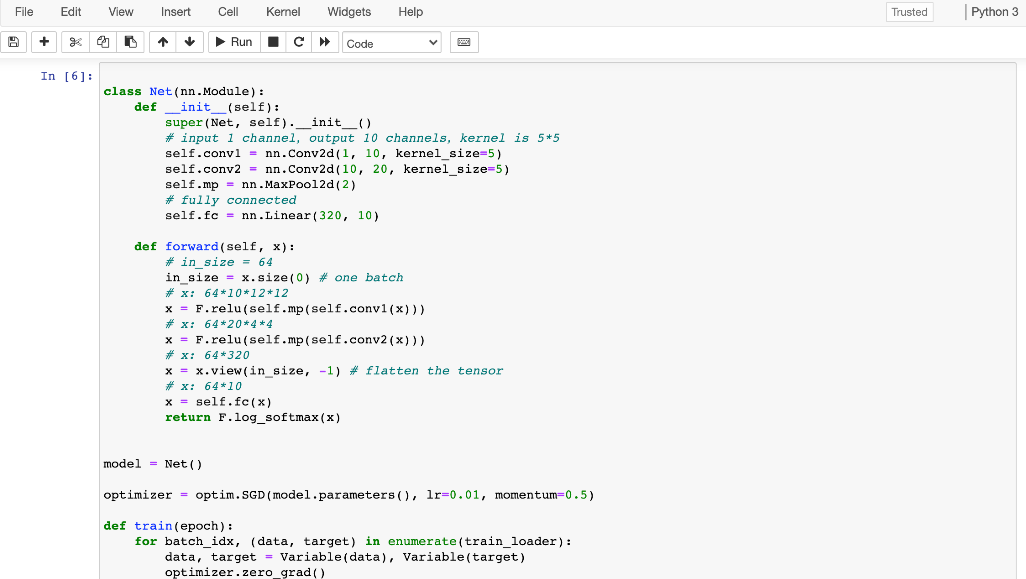

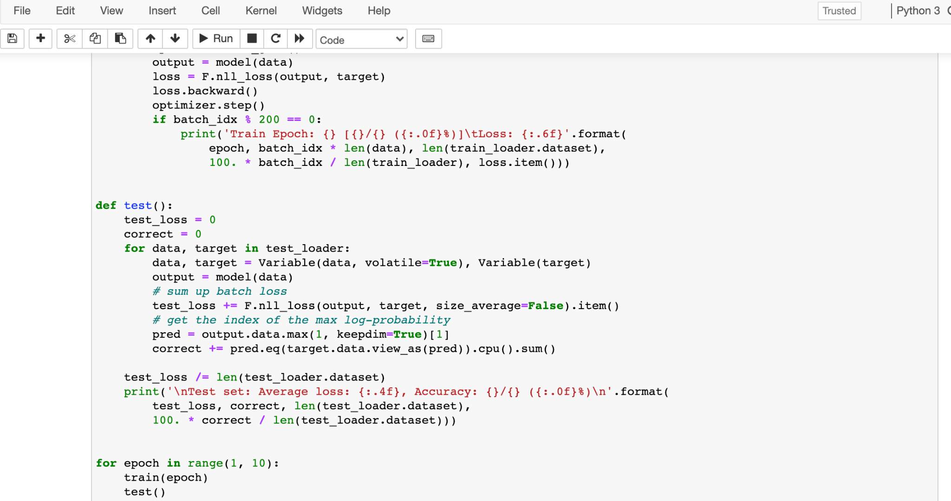Figure 1: CNN Complete Code

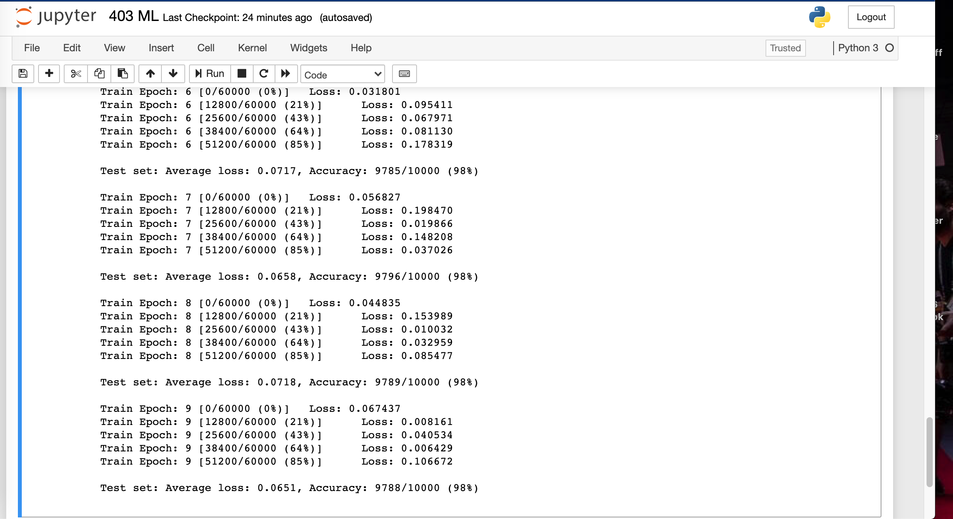Figure 2: CNN Accuracy Scores

For each epoch, the average loss is around 0.06 and the accuracy score stays at 98%. And of course to get to these results, the whole program needs to be compiled with no errors and the hyper-parameters need to be set to the correct level

So this CNN model passed all validation criterias discussed in the previous section.

1. For detecting objects in a live video feed, as mentioned above, I used pre-trained Haar Cascade XML but there was not one for this 3D printer. So this one presented here is to detect human faces and eyes.

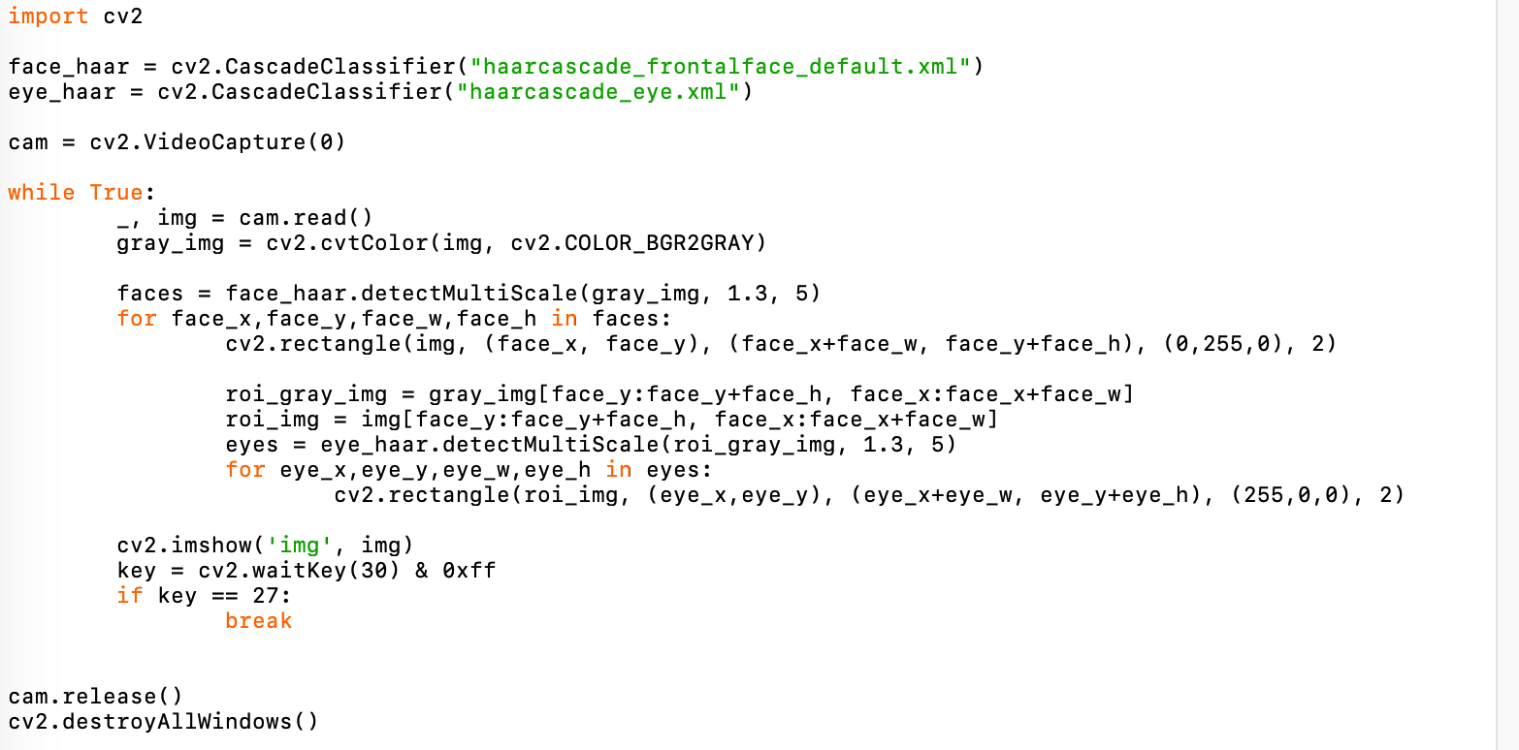Figure 3: Live Video Feed Recognition Code

As you can see, this method has a considerably smaller amount of code to write compared with the CNN model. But it is constrained to what Haar Cascade XML file you use since the parameters generated by Machine Learning methods were already there in the XML file. The following figure is a demonstration of it.

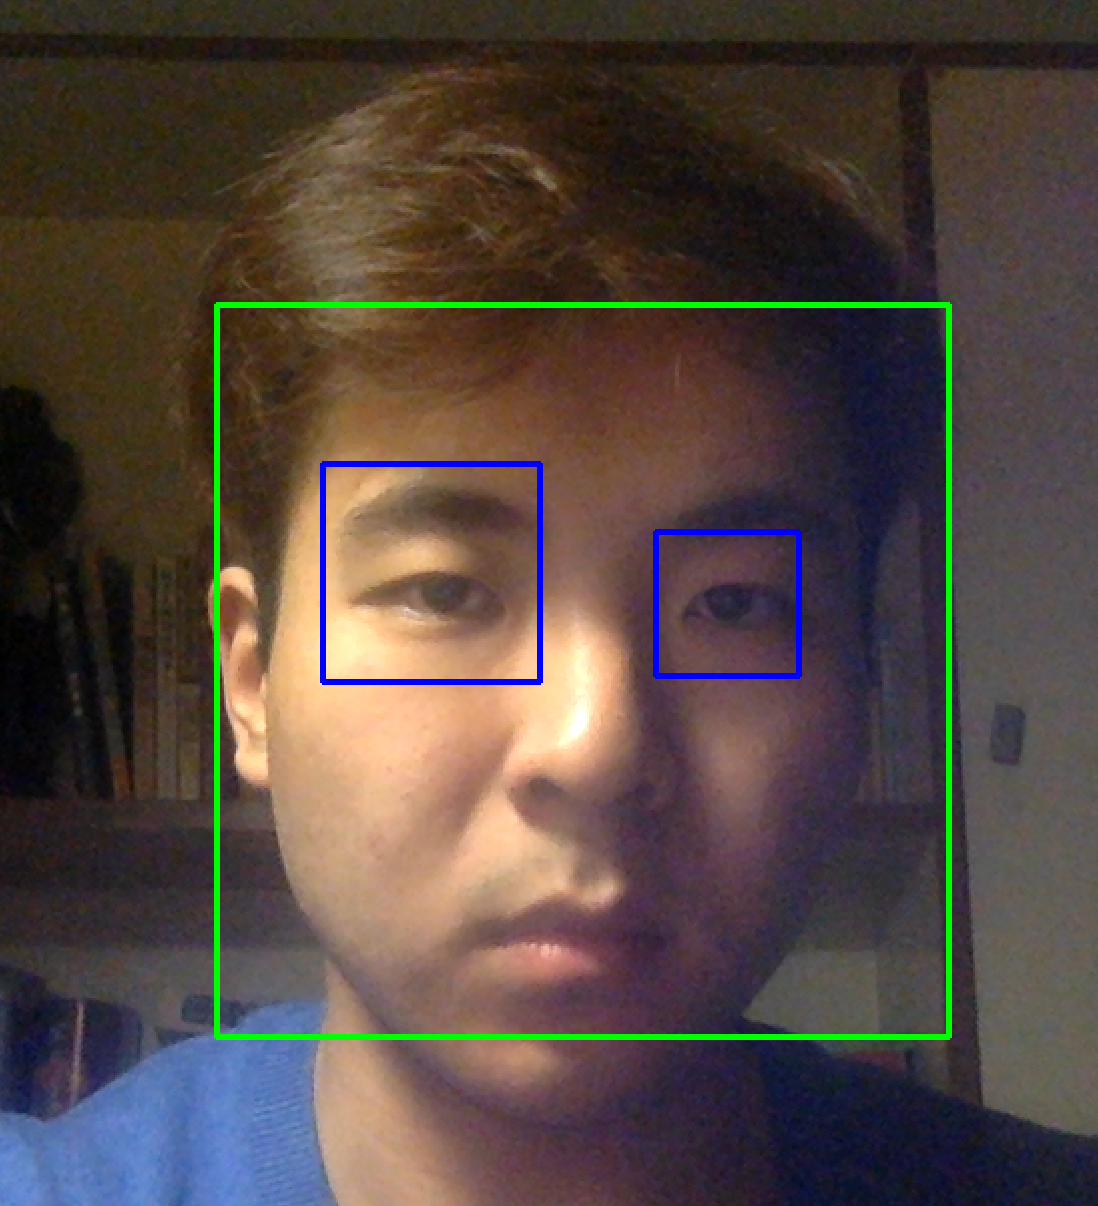

Figure 4: Live Video Feed Recognition Demo

The green rectangle represents that the program detects a human face and blue rectangles represents that the program detects human eyes. And these ‘markers’ will follow you as you move in live video feed. And apparently this code compiled successfully and is working properly and meets the validation criterias.

1. For converting the plain 2D image file to a 3D .STL file so that it could be ready to be fed into the Vuforia engine for object recognitions in Unity, I did it on Google Colab because it will not take up much space on my laptop. The code is shown below.

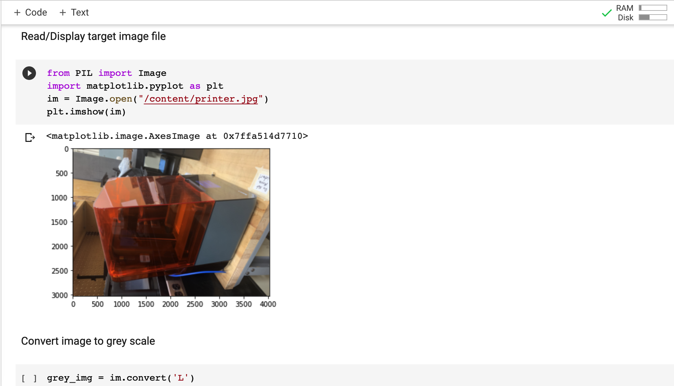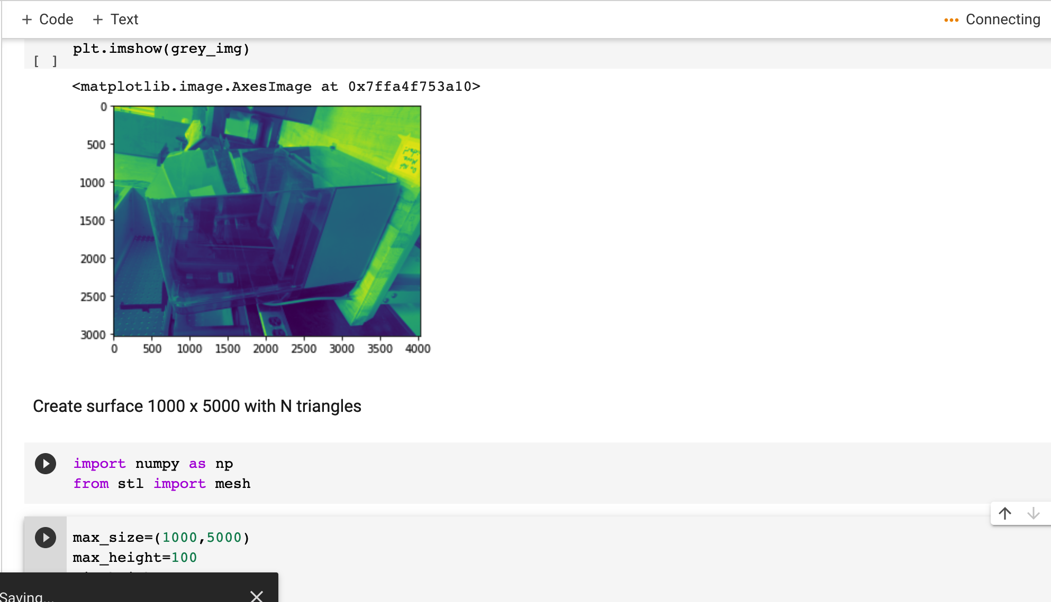

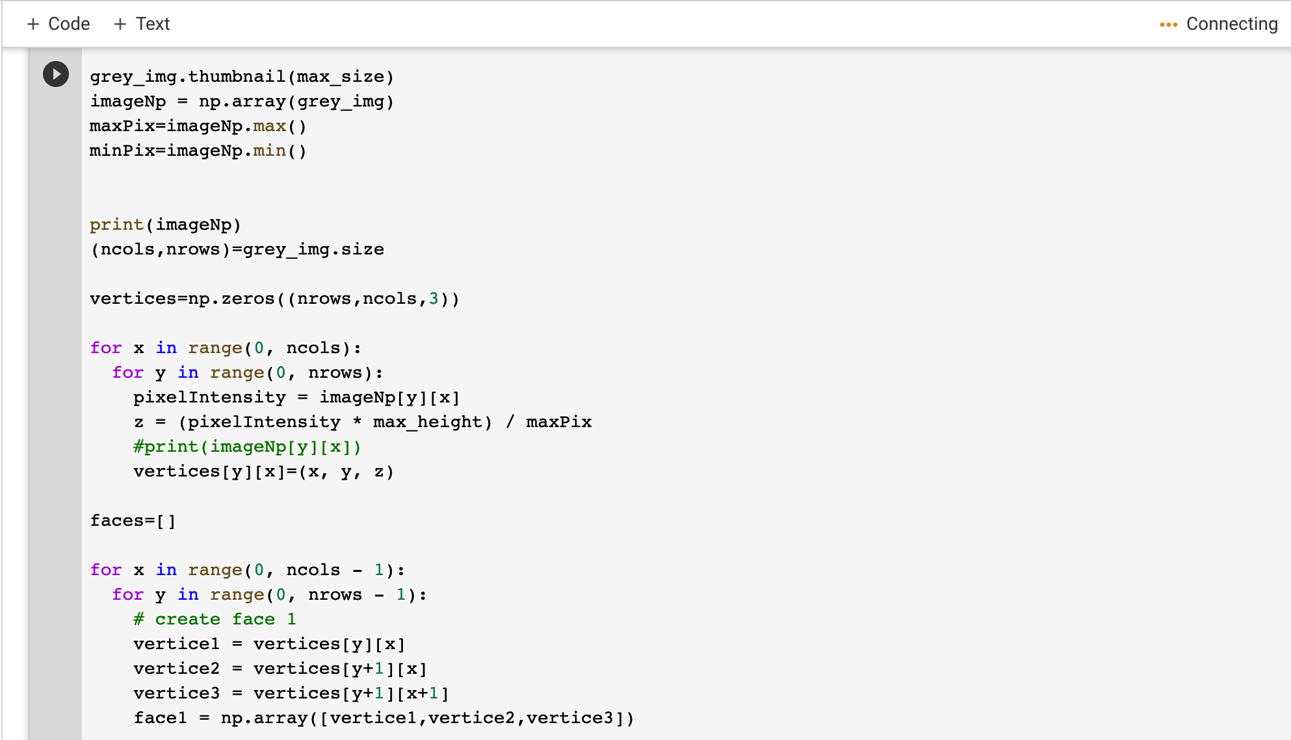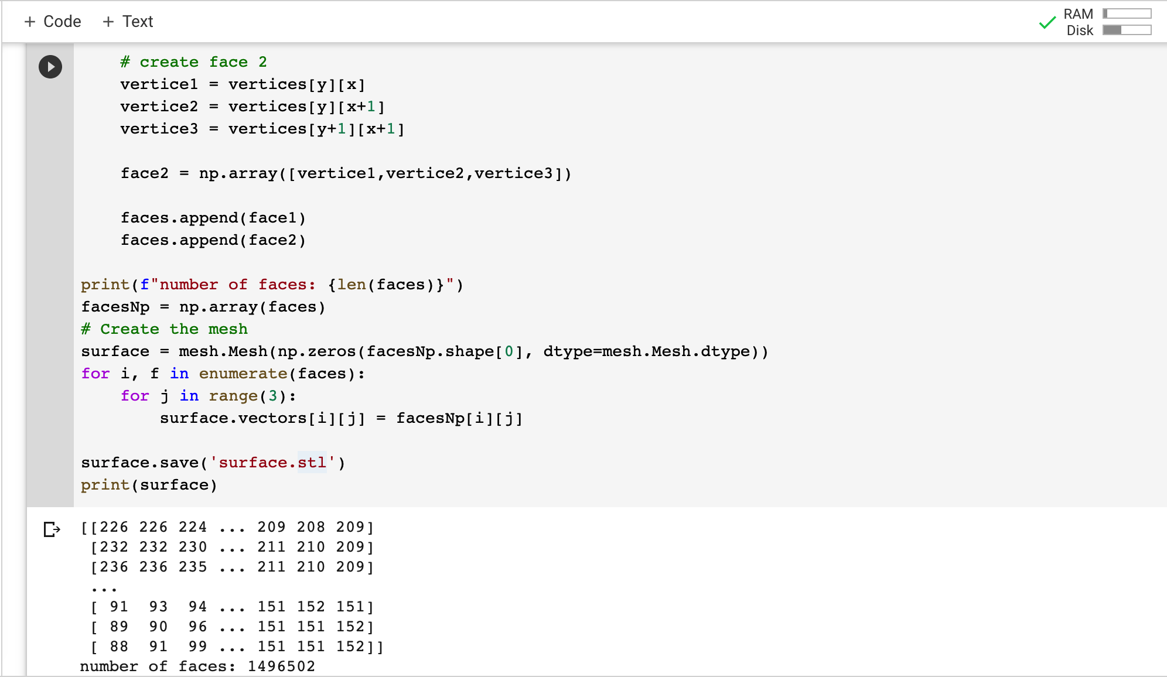

Figure 5: 2D to 3D Conversion Code

After the conversion by creating meshes for each surface, a 3D .STL called surface.stl was generated. As shown below, the conversion was successful and on the left side is the 2D .JPG file of the printer and the one on the right is the 3D .STL file being generated.

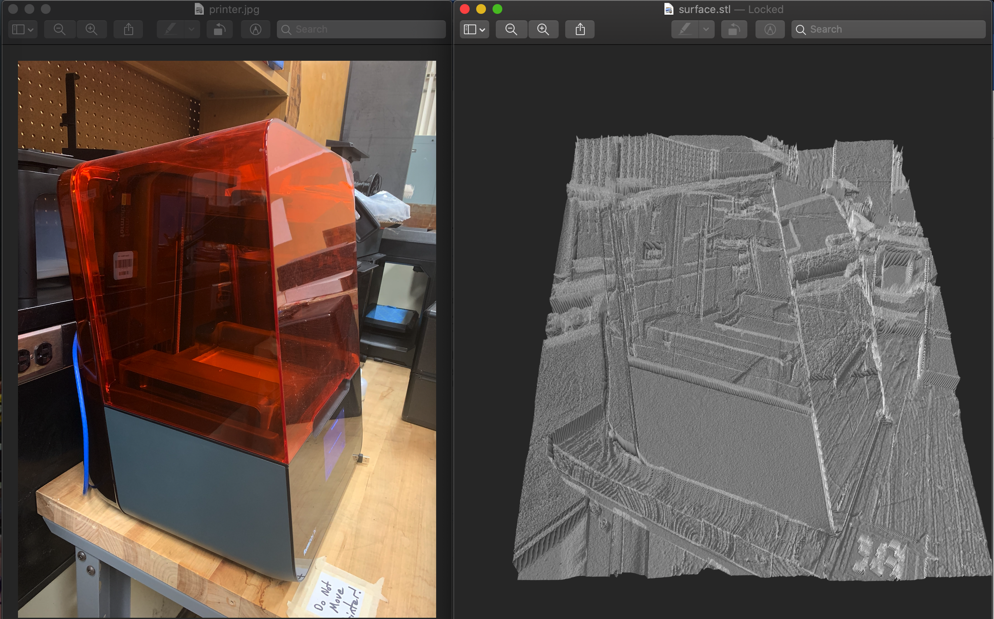

Figure 6: 2D to 3D Conversion Results

1. For implementing Vuforia engine to the Unity environment, there were very subtle settings for many parameters that needed to be taken care of. And fortunately, Vuforia was able to function properly under Unity with other subsystems and recognize the 3D printer as shown below.

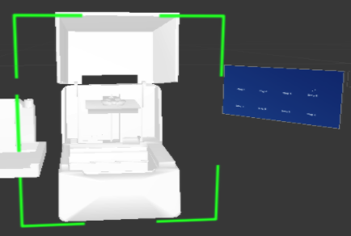

Figure 7: Recognizing 3D Printer Under Unity Simulation Mode

And the figure below is showing the laptop’s webcam identifying the 3D printer under Unity environment with Vuforia successfully implemented.

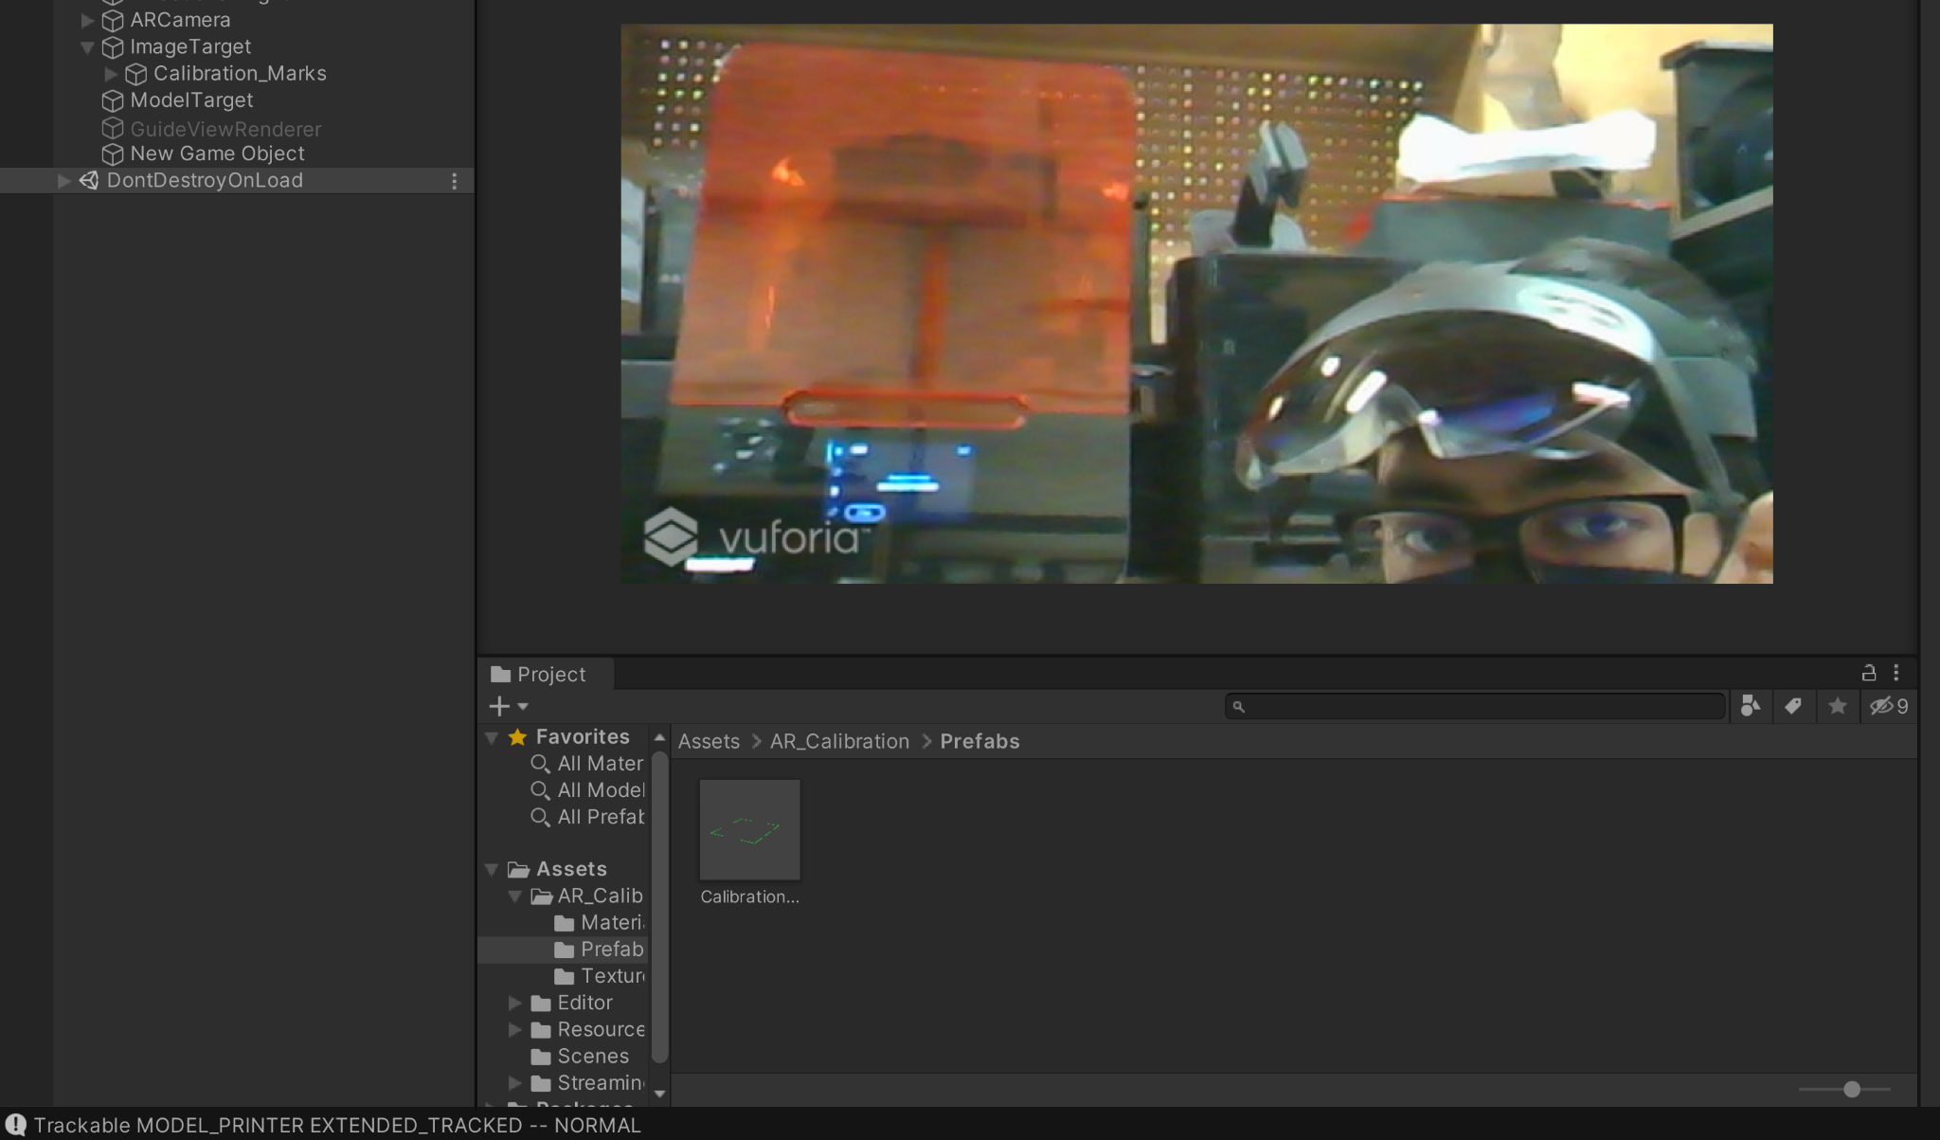

Figure 8: Recognizing 3D Printer Using Unity

* 1. ***Conclusion***

This whole project has been a very challenging one for me and for our whole team. We came in with little or even no knowledge about the device and Unity and have gone to where we are right now, I’m very proud of myself as well as our team.

By doing this project, for me, it was more like a tour of growth and a continuous learning experience. I have learned how to quickly learn a brand new knowledge, machine learning, in this case, and also created implementations based on machine learning techniques.

I have also learned how to work with a team and to maximize our efficiencies when working together. And in this tour of researching and exploring, I am very grateful to have learned so much about machine learning and computer vision in this period of time. Although there were big roadblocks and obstacles, me and our team managed to overcome them one after another.

For example, we did not give up when we felt hopeless and helpless, and finally we found the solution of using Vuforia after only one week of research by reading through articles, PhD papers and several academic forums.

Along the way, I have had the opportunity to make several important decisions and I have to concede there were both good and bad ones. For example, when I first finished the Convoluted Neural Network model I should have realized that python scripts with third party machine learning library will not work or will be extremely difficult to implement into both Unity and the HoloLens 2 device and alternatively, to start searching for an unity engine that can be used directly. And what I was trying to do was actually to build something like Vuforia from the ground up, which is apparently not feasible for undergraduate students.

Last but not least, although we did not have this subsystem deployed onto the HoloLens 2 device due to time constraint and technical difficulties from computer hardware settings, I am proud that we finished strong. More importantly, we got the Computer Vision and Machine Learning subsystem to function properly as well as integrated successfully with other subsystems under the Unity environment. Overall, this project has been an amazing experience for me and I am thankful for everything I have learned during these two semesters.

Natural Language Processing

Jinhao Pan

**Subsystem description and development**

REVISION - Final

April 2021

**Table of Contents**

**Table of Contents 49**

**List of Figures 49**

**List of Tables 49**

1. **Overview/Abstract 50**
2. **Development plan and execution 50**
   1. Plan 51
   2. Actual Data 53
   3. Conclusion 58

**List of Figures**

| Figure 1: NLP In HoloLens 2 52 |
| --- |

**List of Tables**

| Table 1: Plan for NLP subsystem 50 |
| --- |
| Table 2: Fine Tuning Print Commands 53 |
| Table 3: User Commands 55 |
| Table 4: Questions and Responses 55 |
| Table5: Button Functioning 57 |

##### **Overview/Abstract**

There were three main pieces of codes of NLP (c #) under Unity 3D Environment and integrated successfully under Microsoft HoloLens 2: Setting changer, Text changer, and UDP communication. For the text changer code, it would listen to the instructions from users, output the log, change the voice input into a text string, and send the results to the settings changer script.

For the setting changer code, users can input the voice with some basic commands (already converted by text changer), which can allow users to change the setting they want during the process of operating 3D printers, which HoloLens 2 would send these information to the PreForm software via UDP communication with same IP address. In this subsystem, we used Unity MRTK to code specific commands to achieve NLP like using a dictionary to only allow users to change the printing settings, and used built in hand gesture tools in Unity to allow users to immerse in Augmented Reality.

1. **Development plan and execution**

|  | **February 2nd** | **February 16th** | **February 28th** | **March 3rd** | **March 8th** | **April 3rd** |
| --- | --- | --- | --- | --- | --- | --- |
| Execution Plan | Integrate the animation/modelling subsystem into the 3D environment. | Integrate the NLP subsystem into the 3D environment. | Integrate the CV/ML subsystem to be able to recognize the 3D printer. | Testing and debugging CV/ML and Animations and Modelling. | Testing and debugging NLP. | Add finishing touches to finalize the project. |
| Validation Plan | Ensure the user can directly control the animations of the model. | Testing each command, can achieve 60% accuracy | Testing to achieve 80% accuracy and fully functional | Testing to achieve 90% accuracy and fully functional. | Testing each command, can achieve 80% accuracy | NLP for at least 90% accuracy for commands |

Table 1: Plan for NLP subsystem

Yellow highlights showed that I completely finished the execution and validation plans.

* 1. ***Plan***

In the complete system, users would follow the menu, description panel, and animations to click the button to go to the previous step or next step to change in different scenes. The NLP subsystem was designed for the final step (scene) for users after viewing all teaching animation instructions to change the 3D printing settings via voice commands to transfer to PreFrom software. I used built-in MRTK under Unity to code all printing setting commands, help commands and frequently asked questions to let users know how to operate NLP. All changed setting logs would show up in the NLP log. In the MRTK user input speech portal, I coded Fine-Tuning Print Commands, User Commands, and Questions and Responses. The setting changer and text changer will then update via users’ input voice commands to change the setting from defaults. The default setting under C# will be:

public string DensityS = "0";

public string TouchpointSizeS = "0";

public string SlopeModifierS = "0";

public string HeightAboveRaftS = "0";

public string RaftThicknessS = "0";

public string ScaleS = "1";

public string XScaleS = "0";

public string YScaleS = "0";

public string ZScaleS = "0";

public string NewRaftTypeS = "2";

public string OneClickS = "False";

public string AutoOrientS = "False";

public string AutoGenerateS = "False";

public string GenerateLayoutS = "False";

public string UndoS = "False";

public string StartPrintS = "False";

public string RL = "True"; //Raft Label (True/False)

public string IS = "True"; //Internal Supports

Then, I need to put these strings with the correct IP address to send to the computer or any devices running PreForm software that connected the 3D printer already. Then, I modified the previous team’s PreForm integration python code that would receive the message from HoloLens 2 and move the mouse position in the PreForm Software to click to change settings. Even though our sponsor did not require us to finish the PreFrom integration, it was an efficient way to validate the NLP subsystem.

For the validation plan, at the beginning integration stage, I tested a few commands with at least 60% accuracy and focused on combining animations with the subsystem. We put buttons to change each scene, which was just one step of teaching instruction on how to use the 3D printer. We focused more on the distancing and qualities of the animation integration and tested the functionality of buttons, which we tried to click on next step and previous step at least five times, and functioned perfectly. After fully integrating all required subsystems, I tested each command five times after the Unity application was deployed to the HoloLens 2 via Visual Studio and expected at least 90% accuracy to contribute to the whole application properly. I did not want to miss any commands to influence the test results of the subsystem. Thus, I put each command’s accuracy with fraction style in the table (showed in the actual data part). And I wanted to eliminate the possibility of recognizing only one user’s voices, such as mine, so I tested with different users’ voices. Omar tested well with most of the commands without accent, TA tested some commands successfully for user testing, and I tested all commands with my accent. The complete NLP subsystem test results achieved 98% total accuracy based on my voice input.

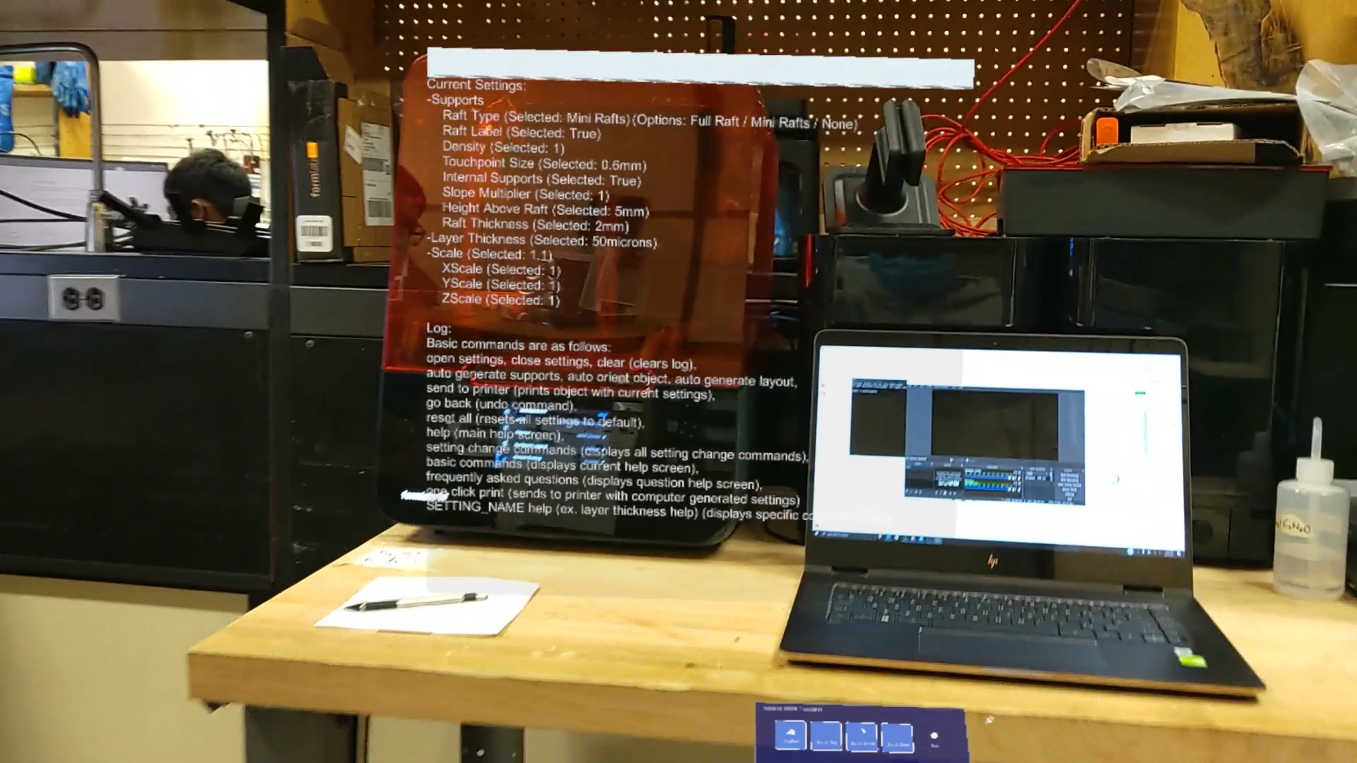

Figure 1: NLP In HoloLens 2

* 1. ***Actual Data***

| “Change raft type: full raft” 5/5 | “Increase scale point five” 5/5 |
| --- | --- |
| “Change raft type: mini rafts” 5/5 | “Decrease scale point one” 5/5 |
| “Change raft type: none” 5/5 | “Decrease scale point two” 5/5 |
| “Toggle raft label” 5/5 | “Decrease scale point five” 5/5 |
| “Toggle internal supports” 5/5 | “Increase x scale point one” 5/5 |
| “Increase density point zero five” 5/5 | “Decrease x scale point one” 5/5 |

| “Increase density point one” 5/5 | “Increase y scale point one” 5/5 |
| --- | --- |
| “Decrease density point zero five” 5/5 | “Decrease y scale point one” 5/5 |
| “Decrease density point one” 5/5 | “Increase z scale point one” 5/5 |
| “Increase touchpoint size point zero five” 5/5 | “Decrease z scale point one” 5/5 |
| “Increase touchpoint size point one” 5/5 | “Change layer thickness 25”  (Micron) 5/5 |
| “Decrease touchpoint size point zero five” 5/5 | “Change layer thickness 50”  (Micron) 5/5 |
| “Decrease touchpoint size point one” 5/5 | “Change layer thickness 100”  (Micron) 5/5 |
| “Increase slope multiplier point zero five” 5/5 | “Reset all” (Resets all values to default.) 5/5 |
| “Increase slope multiplier point one” 5/5 | “Change raft type default” 4/5 |
| “Decrease slope multiplier point zero five” 5/5 | “Change layer thickness default” 4/5 |
| “Decrease slope multiplier point one” 5/5 | “Change density default” 5/5 |
| “Increase height above raft point five” 5/5 | “Change touchpoint size default” 5/5 |
| “Increase height above raft one” 5/5 | “Change internal supports default” 5/5 |
| “Decrease height above raft point five” 5/5 | “Change slope modifier default” 5/5 |
| “Decrease height above raft one” 5/5 | “Change height above raft default” 5/5 |
| “Increase raft thickness point zero five” 5/5 | “Change raft thickness default” 5/5 |
| “Increase raft thickness point one” 5/5 | “Change scale default” 5/5 |
| “Decrease raft thickness point zero five” 5/5 | “Change x scale default” 5/5 |
| “Decrease raft thickness point one” 5/5 | “Change y scale default” 5/5 |
| “Increase scale point one” 5/5 | “Change z scale default” 5/5 |
| “Increase scale point two” 5/5 | “Go back” (Undo) 5/5 |

Table 2: Fine Tuning Print Commands

The user commands are as follows:

| “Auto orient object” 4/5 | “Clear” (Clears log) 5/5 |
| --- | --- |
| “Auto generate supports” 4/5 | “Open settings” (Opens window) 3/5 |
| “Help” (Shows help list) 5/5 | “Close settings” (Closes window) 5/5 |
| “Send to printer” (One-click-print) 5/5 |  |

Table 3: User Commands

The Questions and responses are as follows:

| **Questions** | **Responses** |
| --- | --- |
| “Raft type help” 5/5 | Print your model on a single large raft, multiple large rafts, or the print bed. |
| “Raft label help” 5/5 | The Model name is generated on the raft of the support structure. |
| “Density help” 5/5 | Changes the number of touchpoints between your model and the support structure. |
| “Touch point size help” 5/5 | Changes the diameter of points where support structure and model meet. |
| “Internal supports help” 5/5 | Internal supports are supported with both ends touching the model. |
| “Slope multiplier help” 5/5 | Changes the density of support structures for surfaces set at an angle. |
| “Height above raft help” 5/5 | Changes how high a model sits above the raft. |
| “Raft thickness help” 5/5 | Thickness of the raft affects how a print |
|  | stays connected to the build platform. |
| “Layer thickness help” 5/5 | Layer thickness affects speed and quality. Thicker layers print faster but lose detail. |
| “Scale help” 5/5 | Changes the scale of the object. |
| “How do I know my part is ready to print” 5/5 | Wait for the printer to display 'Ready'. |
| “How long do I let my object drip” 5/5 | Time depends on the complexity of the print, 1 hour - 1 day. |
| “When do I break the part from the supports” 5/5 | After washing and before curing. |
| “How long should I wash and cure” 5/5 | Refer to manual. |
| “How do I print” 5/5 | Step one: When object is ready, select print on printer, Step two: wait for printing process, Step three: wash object in washer, Step four: Break supports, Step five: Cure in curing machine. |
| “How do I clean nozzle” 5/5 | Remove nozzle from bottom right of the resin container and scrape off dry resin. |
| “When do I replace the resin” 5/5 | Remove tray and check if resin is cloudy after swabbing. |
| “How do I replace the resin” 5/5 | Pull the old container up and out from the back of the printer and replace. |
| “What can go wrong during a print” 5/5 | Possible printing errors: Nozzle jam | Resin could be bad | Resin runs out. |

Table 4: Questions and Responses

| Button 1 5/5 | Button 2 5/5 |
| --- | --- |
| Button 3 5/5 | Button 4 5/5 |
| Button 5 5/5 | Button 6 5/5 |
| Button 7 5/5 | Button 8 5/5 |
| Button 9 5/5 | Button 10 5/5 |
| Button 11 5/5 | Button 12 5/5 |
| Button 13 5/5 | Button 14 5/5 |
| Button 15 5/5 | Button 16 5/5 |
| Button 17 5/5 | Button 18 5/5 |

Table 5: Button Functioning

Outcomes:

* **NLP**

80 total commands

Accuracy tested = (400 – 6) / (80*5) = 0.985 = 98.5%

* **Buttons**

All buttons worked perfectly by clicking five times each. 100% accuracy.

* 1. ***Conclusion***

In this project, I learned and touched on the basic ideas about natural language processing, in which people can use commands to do some specific things. And this concept would be more and more valuable and popular in the future. NLP can be done by mixing with machine learning and Artificial Intelligence to achieve more functions and generate more usages. I also learned that I could improve the current NLP system, in which I can code more voice commands in MRTK to control the buttons to change scenes at least or other components. Also, I can connect Amazon AWS to do more powerful and functional NLP.

Since Unity and HoloLens 2 are only compatible with C#, I researched and learned how to write C# script to use in Unity to change scenes and output and update logs, and use UDP IP address to communicate with other devices. I learned that there is a way to make Unity compatible with Python 2. However, it required extra packages of Unity, and you cannot actually write in Python 2 style code, which you still needed to use Unity engine and some library, which was more C# style. Then, we could not implement the python codes to achieve the computer vision part. I researched using the Vuforia engine to serve the computer vision in Unity. This engine would directly recognize the model user put and show the signal if the object matched. I learned how to use the Vuforia developer functions to transfer the 3D printer model to the 3D model that Vuforia accepted using Model Target Generate. Then, I learned that using Visual Studio debugging mode to deploy unity applications to HoloLens 2 instead of using Wi-Fi was faster and more effective. We just put the IP address correctly and used the solution file built by UWP. Since we still cannot find out why the Vuforia engine could not work, our sponsor told us that it was unnecessary to finish just focusing on other subsystems and user testing. He mentioned he would continue the cv part by using a potential alternative way named StereoKit. I learned this implementation would just recognize the QR code and track it with accurate position identification. In general, I realized that we should communicate more with our TA, our sponsor. Under the pandemic, we had limited access to the WEB lab room. We still needed to plan accordingly and beforehand.

There were not a lot of key decisions about NLP since the collected data showed that the total accuracy of NLP was always optimal since last semester and even with the previous team. I decided to make the NLP suitable in the newest version of Unity first. Then I made sure it worked by letting different people input different voice commands to see if the system could recognize voice commands without discrimination like only know my voices. And I got the test results by testing all the coded commands and recorded the results. The test results were optimal, and the whole NLP part was very successful. For the entire project, we encountered that python could not be used in this project; I did the research and tried to replace python by using Vuforia Engine, though this decision did not achieve to integrate successfully. And I made a decision to connect PreForm to HoloLens 2 NLP system to show the demo how the whole thing worked, though our sponsor did not require me to finish this part.

3D Augmented Reality Environment

Omar Quabili

**Subsystem description and development**

REVISION - Final

April 2021

**Table of Contents**

**Table of Contents 61**

**List of Figures 61**

**List of Tables 61**

1. **Overview/Abstract 62**
2. **Development plan and execution 62**
   1. Plan 62
   2. Actual Data 63
   3. Conclusion 65

**List of Figures**

| Figure 1: Active NLP Log 63 |
| --- |
| Figure 2: First Iterations Initialization Step 63 |
| Figure 3: New Iteration Testing 64 |

**List of Tables**

| Table 1: Testing and Validation criteria 65 |
| --- |

1. **Overview and Abstract**

The 3D Augmented Reality Environment serves as the foundation for implementation. It serves as the focus point for integrating the remaining three subsystems: Natural Language Processing, Computer Vision, and Animation/Modelling. Once all three subsystems are completely integrated, the steps required to set up a print for the FormLabs Form 3 3D Printer are designed and implemented into the main application. The resulting application will be able to properly guide any untrained user through the preparation steps of setting up a print. The application then ends by presenting the user with a console log detailing the precise measurements of the print. Here, the user will be able to alter these measurements with just their voice. The application also uses accurate 3D models of the printer and allows the user to view them from any angle. With all these aspects taken into account, the 3D Augmented Reality Environment’s role as the foundation is essential for user interface readability and operation.

1. **Development Plan and Execution**

* 1. ***Plan***

The overall plan for integration was to implement each subsystem one at a time and debug errors along the way. This was done to minimize the otherwise overwhelming errors that would have occurred if all subsystems were included at the same time. This also allows for each respective subsystem to be custom tailored not only to be compatible with the HoloLens, but also to fit well with the main application.

First, the Animations/Modelling subsystem was implemented. I worked closely with Vy to optimize aspects such as the model scales, viewing angles, clarity of animations, and ease of use.

Second, the Natural Language Processing subsystem was integrated into the main application. I worked with Jinhao to add a console log which allows the user to make intricate changes to the desired print model. The speech handler scripts are attached to the main camera in the Unity environment and I/O was handled by another text changer script which outputs the changes the user made to the console log.

Third, the Computer Vision subsystem was added. I worked with both Jinhao and Qingboyuan in trying several solutions to initialize a machine learning algorithm to detect the 3D printer upon the start of the application. The Vuforia Engine was then set up to start on the main camera of the HoloLens. As mentioned above, the Vuforia Engine was tested and validated working on a webcam in the Unity editor. However, the engine does not work on the actual HoloLens unit. Our sponsor advised us to focus on validating other parts of our application and to leave the CV aspect behind for him to handle later.

* 1. ***Actual Data***

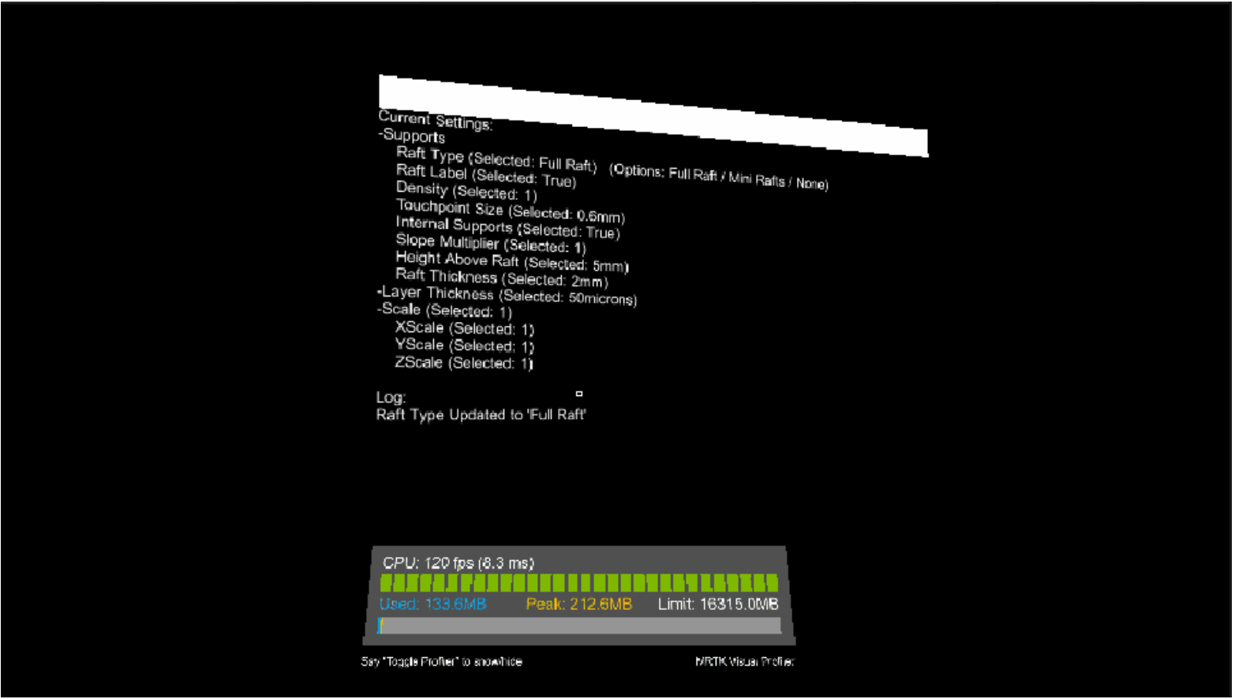

Figure 1: Active NLP Log

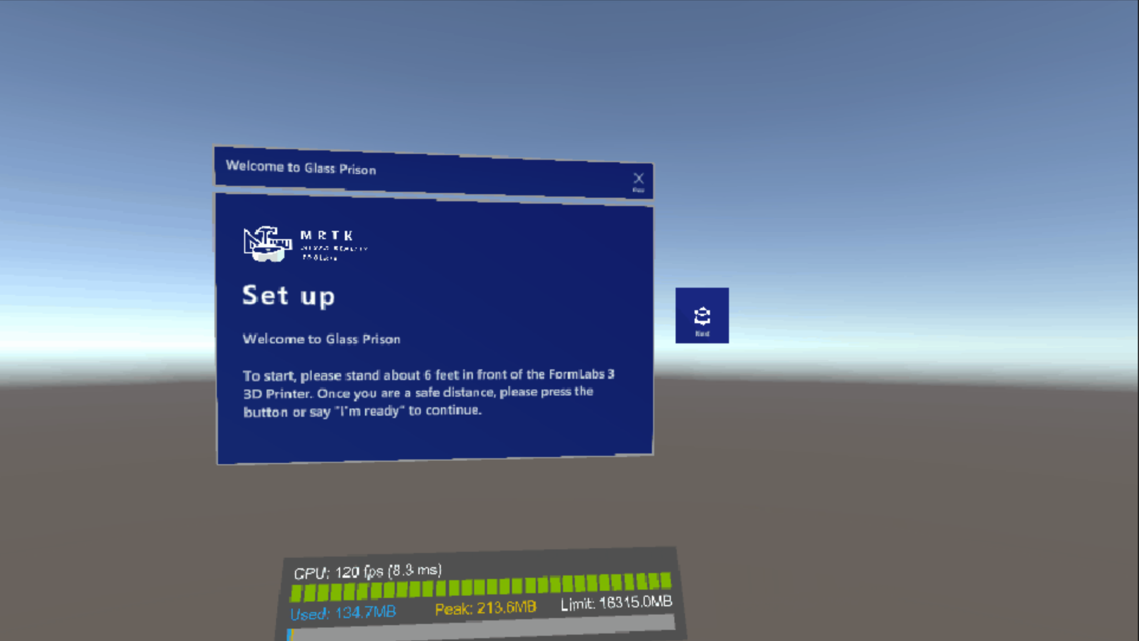

Figure 2: First Iterations Initialization Step

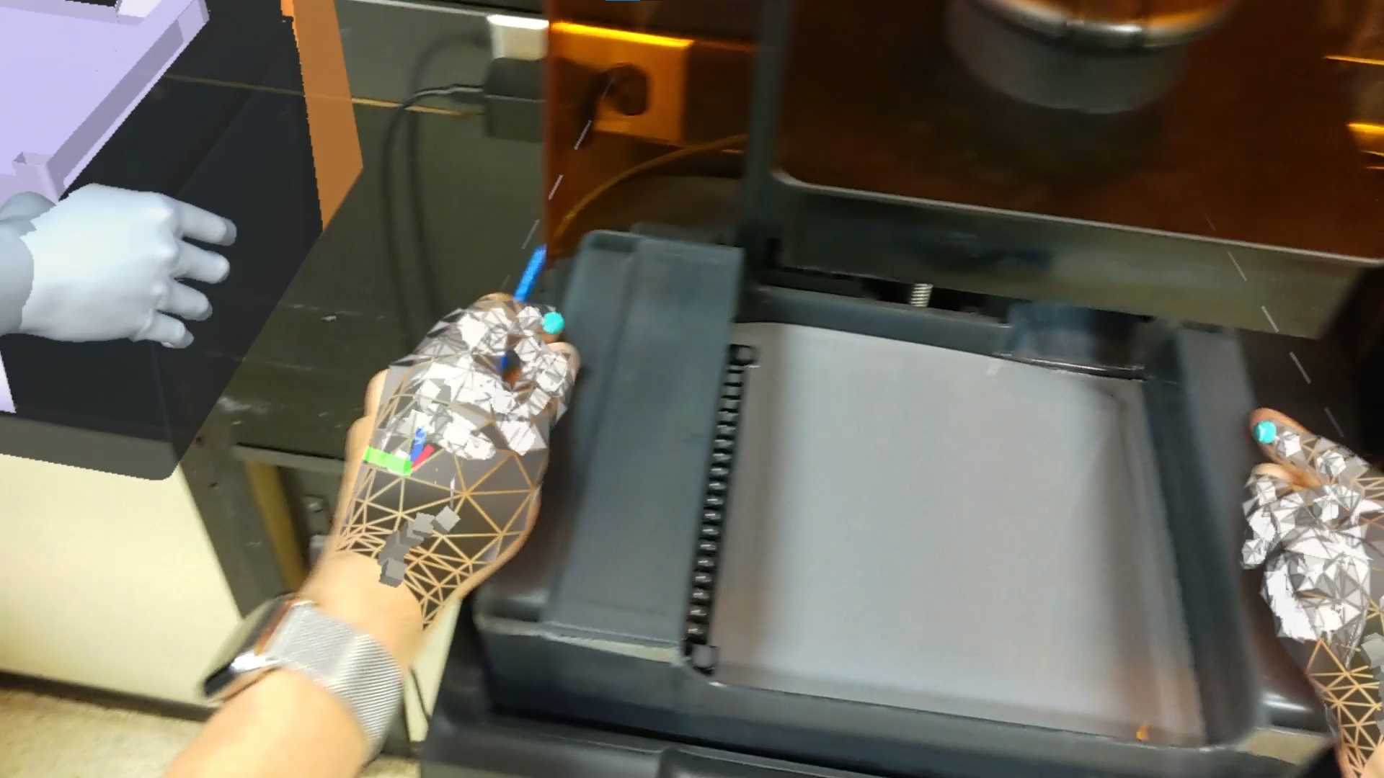

Figure 3: New Iteration Testing

There were two major iterations of this application that were tested through this semester. The first application features a large movable menu that the user is able to resize and manipulate. The menu had each step of preparing for a print attached to a button for a total of eight buttons on the menu. When a button is pressed, the corresponding step will loop in the model’s animation until the user selects another step. There were several concerns with this method. If the user were to press the wrong button, there is little the user can do to backtrack as, ideally, he or she wouldn’t be able to determine the order of the steps and adjust accordingly. Also, all the animations returned to its original state of the first animation regardless of which animation was being played. This error made the animations rather unclear. I then created a second iteration of the application. This application featured eight different scenes including an introduction scene. I also created a smaller menu that follows the user around no matter the position. On the menu, I attached two buttons: a next step button and a previous step button. I wrote a C# script that allowed the user to transition between scenes at the click of a button. This method showed to be significantly more efficient.

There was a minor error that our team could not finish in the span of this semester. Due to the CV not being able to be integrated as mentioned above, there were problems with each scene initializing correctly. When the user would press the next step button or the previous step button, the next scene would initialize in the direction the user is facing rather than using the FormLabs Form 3 3D Printer as an anchor point. Our sponsor advised us to leave the issue for him to handle and progress with validation of the application as a whole.

* 1. ***Conclusion***

Overall, the integration of the other components was successful, save for the CV and machine learning subsystem. The strategy to implement each subsystem one at a time and debug errors through the process showed to be an extremely effective method. Bugs and errors were able to be easily targeted and their fixes were implemented very quickly. The testing and validation criteria below show what the team has accomplished by the time of the final demonstration.

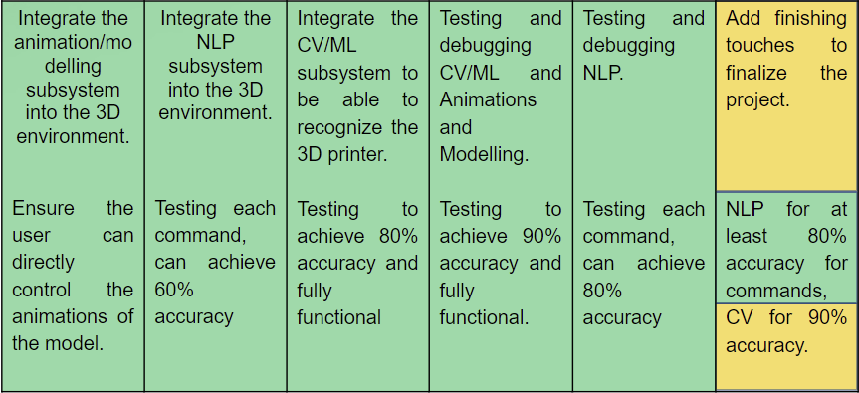

Table 1: Testing and Validation criteria

If all subsystems were to be integrated at once, the myriad of errors would be nearly impossible to track and it would require an unnecessary amount of time to fix. In the end, our sponsor tested our system himself and was satisfied with both interactibility and ease of use.

Animations and Modeling

Thien Vy Tran

**Subsystem description and development**

REVISION - Final

April 2021

**Table of Contents**

**Table of Contents 67**

**List of Figures 67**

**List of Tables 67**

1. **Overview/Abstract 68**
2. **Development plan and execution 68**
   1. Plan 68
   2. Actual Data 69
   3. Conclusion 75
3. **References 76**

**List of Figures**

| Figure 1: Front of Printer 69 |
| --- |
| Figure 2: Printer Open 70 |
| Figure 3: Printer Tray 70 |
| Figure 4: Printer Cartridge 71 |
| Figure 5: Step 1) Opening the Hood 71 |
| Figure 6: Step 2) Inserting Printer Tray 72 |
| Figure 7: Step 3) Lifting the Lever 72 |
| Figure 8: Step 4) Remove and Clean Printing Platform 73 |
| Figure 9: Step 5) Close the Lever 73 |
| Figure 10: Step 6) Close Hood 74 |
| Figure 11: Step 7) Insert Printer Cartridge and Open Tab 74 |

**List of Tables**

| Table 1: Execution and Validation Plan: Animations and Modelling 75 |
| --- |

1. **Overview and Abstract**

The Animations and Modeling subsystem is the visual portion of the augmented reality space. These two in conjunction are used to instruct first time users how to set up the FormLabs Form 3 3D printer. The goal for this subsystem is to create an accurate representation of the 3D printer and the parts needed to operate it. Using models to represent the parts and the physical printer is one of the clearest ways to show instructions. It leaves little room for the user to make mistakes when handling the printer. Along with the animations, if the user were to follow the models and animations, the instructions for operations should be extremely clear. Animations and Modeling were done using Blender 2.90. I chose to use this platform due to the ease of integration into Unity. These two platforms work extremely well together making testing and integration more efficient.

1. **Development Plan and Execution**

* 1. ***Plan***

The plan for this subsystem was to first do research on the printer. This was important because due to covid there was limited access to the lab. I was able to find pictures and obtain videos of the printer and parts at all different angles. This reduced the amount of time that I needed to spend in the lab. Then I learned how to operate the printer in order to instruct a user to replicate the process.

To begin modeling the printer, first I had to learn how to use Blender 2.90. Basic operations such as creating meshes, combining and creating vertices were easily learned using online resources. Then I was able to create a simple form of the printer. After the shape of the printer was completed, I learned beveling, material augmentation, and many other Blender options to detail and complete an accurate representation of the FormLabs Form 3 3D printer.

After the models were complete, I proceeded to the Animations portion of the subsystem. This was done with the integrated animations within Blender. Applying joints to the point of rotation of the components or the center of mass allowed the parts to be manipulated. Then a model of a hand was obtained from Free3D.com and was imported into the file. Applying the armature to the hand and weighting it to the armature allowed the hand to be manipulated by each joint. I chose to assign the parts to rotations, center of mass, and joints in order to make integration of future animations or changes to animations more efficient. I also changed the material of the faces that represented the areas that should be cleaned(green) and the areas that should not be touched(red). This method seemed to be the most clear way to instruct the user and therefore was implemented. Then keyframes were used to mark the position of the printer and hands at certain times allowing detailed animations to be created.

* 1. ***Actual Data***

For this subsystem, I included the screenshots of the printer(and components) at a rest and during each step of operation. The execution was completed in sequential order as follows in the plan. Validation was first done within each environment after the models and animations were complete. The order they were completed in, is as follows, Blender, Unity, HoloLens deployment, and user testing. After the validation was complete, changes were made to the animations and models to make them more clear and accurate.

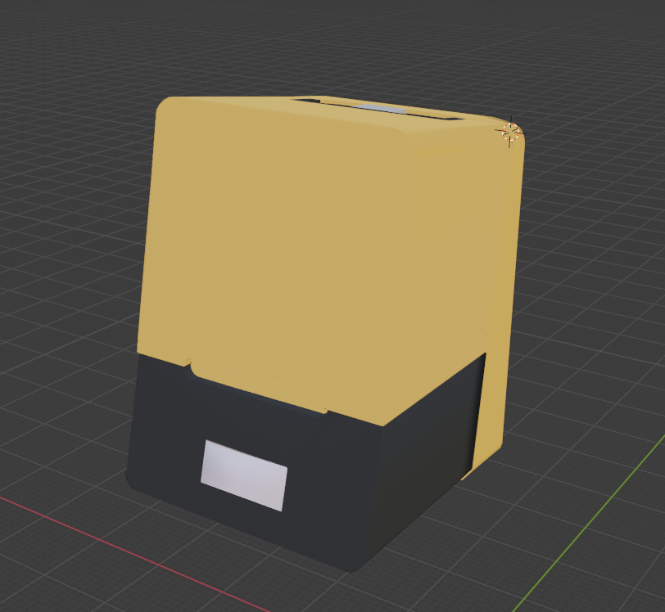

Figure 1: Front of printer

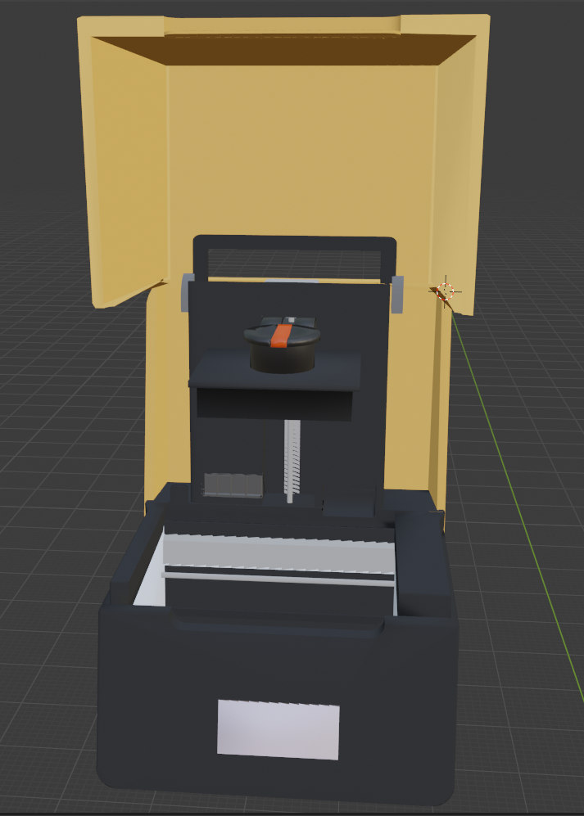

Figure 2: Printer open

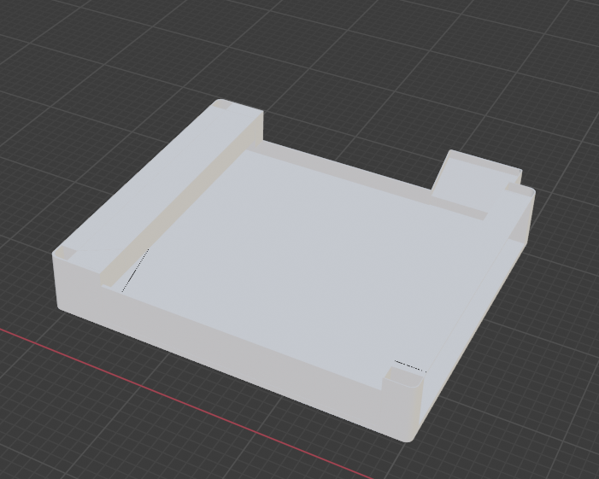

Figure 3: Printer Tray

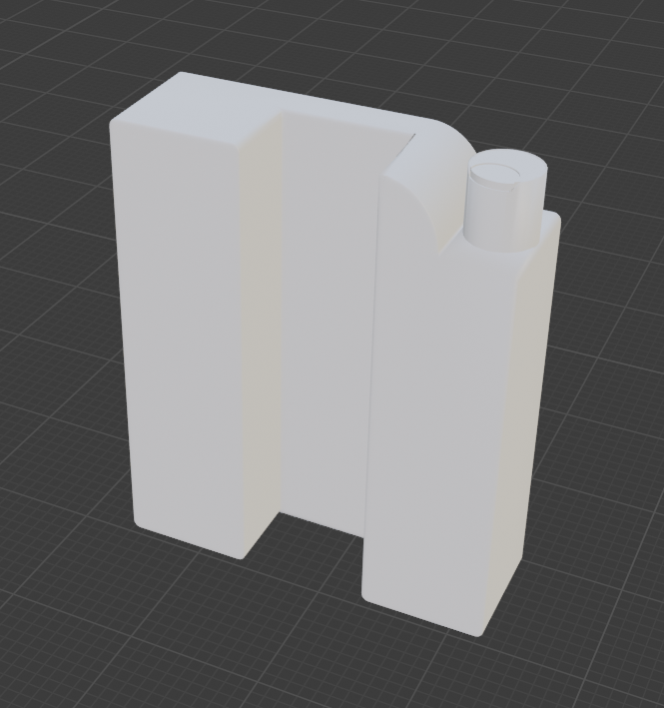

Figure 4: Printer Cartridge

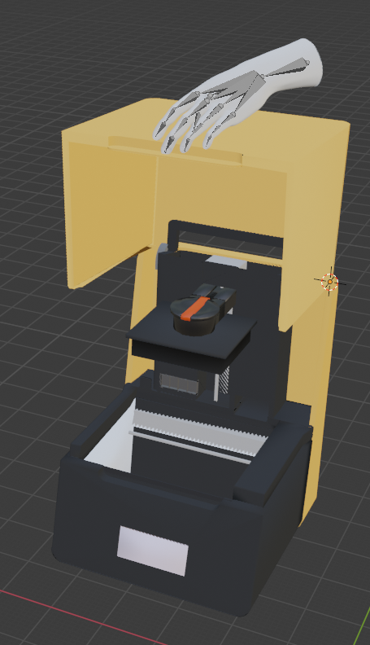

Figure 5: Step 1) Opening the hood

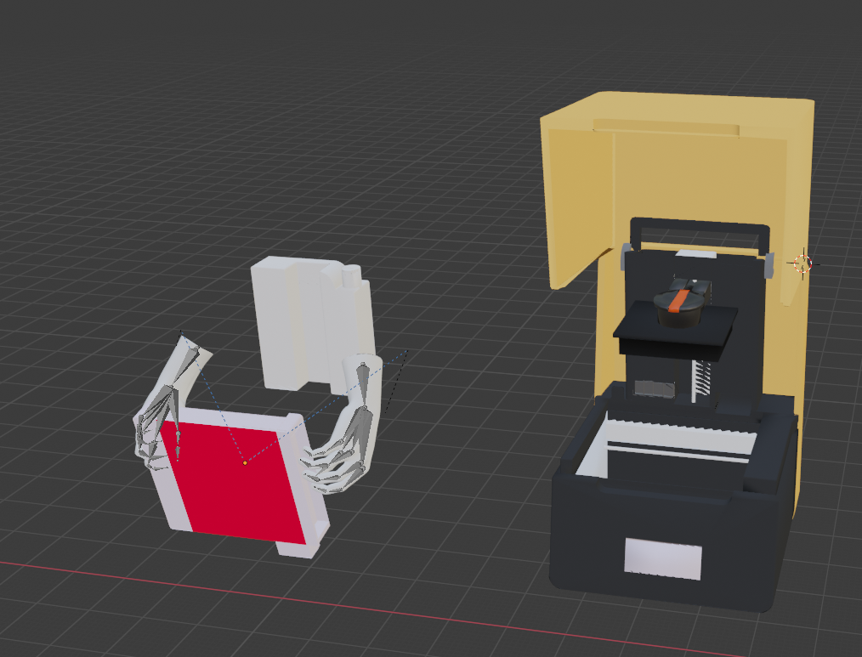

Figure 6: Step 2) Inserting the printer tray

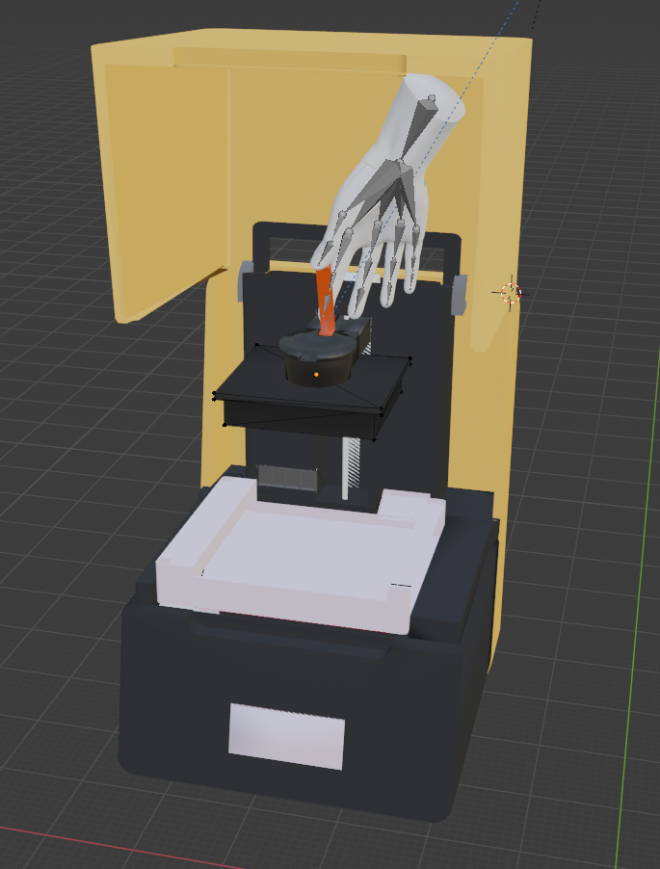

Figure 7: Step 3) Lift the lever

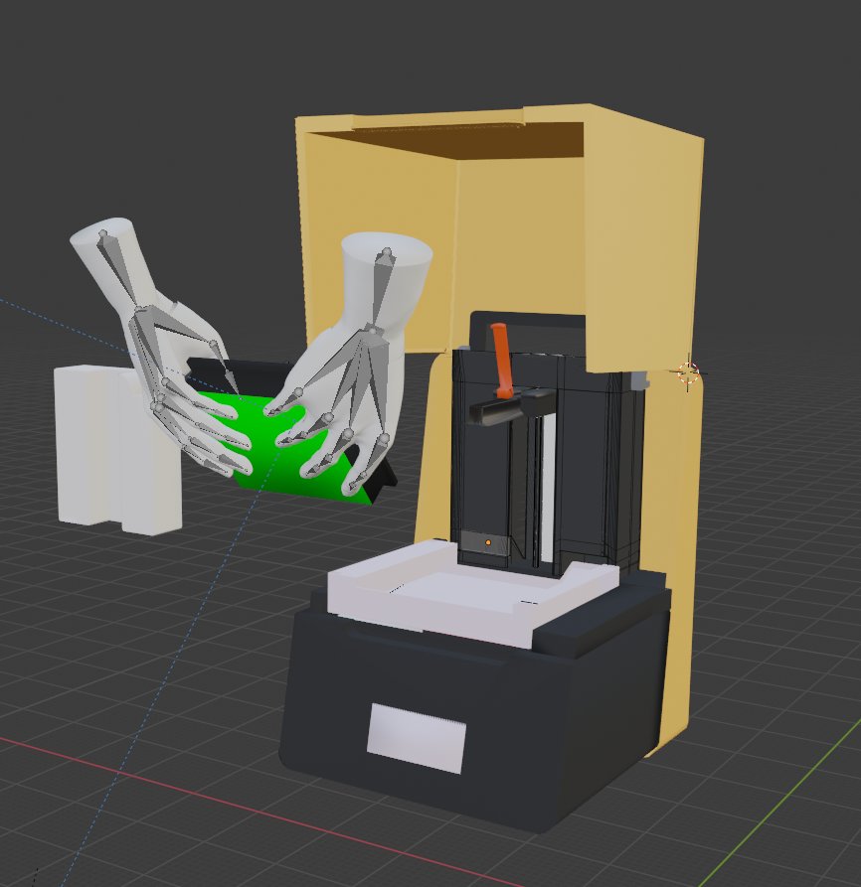

Figure 8: Step 4) Remove and clean printing platform

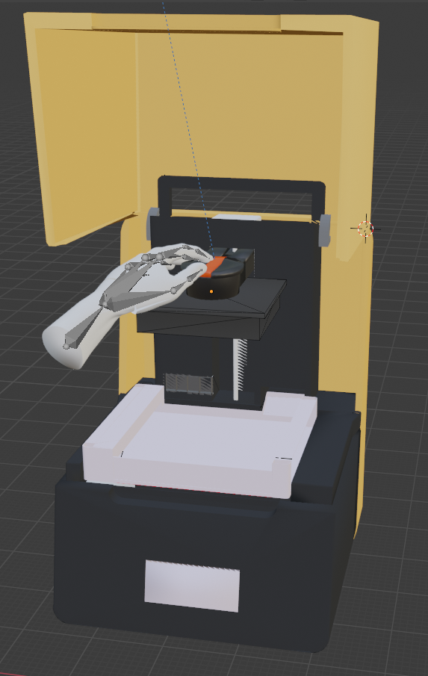

Figure 9: Step 5) Close lever

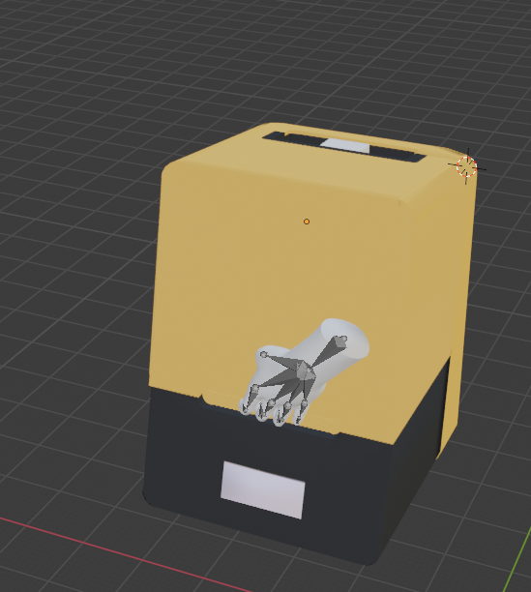

Figure 10: Step 6) Close hood

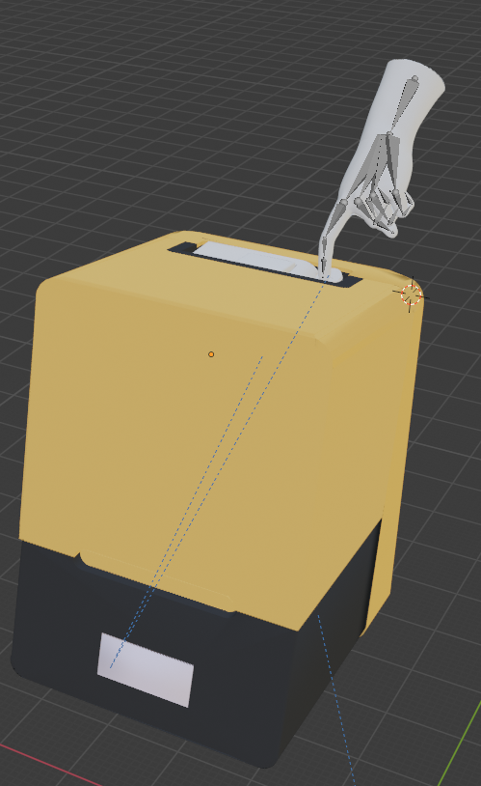

Figure 11: Step 7) Insert Printer Cartridge and open tab

##### 

|  | **February 2nd** | **February 16th** | **February 28th** | **March 3rd** | **March 8th** | **April 3rd** |
| --- | --- | --- | --- | --- | --- | --- |
| Execution Plan | Ensure all animations and models are complete within Blender | Integrate within Unity and ensure all models and animations are functioning in the 3D environment | Deploy onto HoloLens and readjust accuracy of printer and components | Make final changes to improve clarity. | Obtain feedback from as many users as possible and make changes if necessary | Add finishing touches to finalize the project. |
| Validation Plan | Models and animations should be fully functionally within 3D rendering | Animations and models are 100% visible and functionally in 3D environment | Subsystem should be completely integrated into application with no issues | Changes to subsystem should be tested for feedback from teammates | Obtain feedback from sponsor and first time user | Have a first time user successful operate the printer without interference |

Table 1: Execution and Validation Plan: Animations and Modeling

I was able to complete all of my validation and complete the execution plan in a timely manner. Feedback was obtained from as many people as we could. These people consisted of three teammates, our sponsor, and a first time user. This number was extremely limited due to lab access and covid restrictions. However, this subsystem was able to be completed before the deadlines listed.

* 1. ***Conclusion***

In conclusion, This subsystem was completed and integrated completely. This was the first subsystem to be integrated into the 3D environment. The only trouble that I ran into during integration was that there were some faces that would not appear within Unity. This problem was quickly solved in Blender by flipping the normal.

Working on this subsystem allowed me to work with the other team members and the users that tested our project. This has taught me how to improve my subsystem when given feedback. During the development of my subsystem, I worked closely with the 3D Augmented Reality Environment subsystem to ensure that all models and animations were visible and clear from all angles. This allowed me to work more efficiently with the knowledge of Unity that was given to me from my teammate. Lessening the work for him and ultimately making this process more efficient.

From this I was able to learn how to communicate in a new way. Being able to test this the application with different people allowed me to further improve the animations to provide clarity. Creating the models and animations was tedious but well worth the time. The models and animations clearly depict the instructed and when tested by first time users, the feedback was well received. They were able to follow the instructions and in conjunction with the NLP subsystem, users were able to follow the steps for operation. Overall, this subsystem was successful and I was able to learn new skills.

1. **References**

1. Model of hand: https://free3d.com/3d-model/freerealsichand-85561.html

All Systems

Omar Quabili, Thien Vy Tran, Jinhao Pan, Qingboyuan Wang

**Subsystem description and development (Group Report)**

REVISION - Final

April 2021

**Table of Contents**

**Table of Contents 78**

**List of Figures 78**

1. **Overview/Abstract 79**
2. **Development plan and execution 79**
   1. Plan 79
   2. Actual Data 80
   3. Conclusion 82
3. **Github Link 83**

**List of Figures**

| Figure 1: Application Start-Up 80 |
| --- |
| Figure 2: Lift Hood Animation 81 |
| Figure 3: User Directly Lifting the Hood 81 |
| Figure 4: NLP Console Log 82 |

1. **Overview/Abstract**

As mentioned in the previous subsystem reports, the Computer Vision, Animations/Modelling, and Natural Language Processing subsystems were integrated into the Unity 3D Environment subsystem. Each of these subsystems were implemented one at a time to simplify bug squashing and minimize overall compatibility errors. The entire application went through two major iterations which simplified the user interface to promote accessibility and ease of use. The final application itself consists of two major phases. The first phase walks the user through setting up for a print. This involves utilizing animations to demonstrate how to properly insert the printer tray into the 3D printer, how to clean the printing platform, and how to plug in the resin cartridge. The second phase prompts the user with a console log which displays the current print settings that are on the PreForm software. Using a UDP connection and the user’s voice, very specific adjustments can be made to the print without having the user possess previous knowledge of operating the PreForm software. Overall, the application walks the user through the beginning to the end of starting a print with little to no knowledge of 3D printing to begin with.

1. **Development plan and execution**

* 1. ***Plan***

Once all three major subsystem components have been integrated into the Unity 3D Environment subsystem, the application still needed to be built in such a way that it was completely compatible with the Microsoft HoloLens 2 unit. For this to happen, several tools were needed to make sure a proper and compatible build was produced.

First, the Mixed Reality Toolkit needed to be added to the overall Unity project. This specific component allows for Unity to develop in a 3D AR space and also includes several prebuilt tools that are essential for augmented reality development. The toolkit also included optimization features which prevents compatibility issues between shaders and textures and also checks to make sure all the proper settings are applied to ensure a valid build.

Second, Visual Studio 2019 needed to be installed with MSBuild, ARM64 compilation handlers, and Universal Windows Platform build support. These tools are needed to convert for both building and deployment to the HoloLens unit.

The process to build and deploy a package to the HoloLens is relatively straightforward. First, in Unity, a Universal Windows Platform build needs to be made. Once the build is complete, open the solution file in Visual Studio 2019. In the Remote Machine dropdown menu, edit the configurations. Here, the IP address of the HoloLens must be set as the target destination of the deployment target. Then click on the debug dropdown menu and click start debugging. Overall, the build and deployment takes about five minutes and the application will automatically start on the HoloLens.

* 1. ***Actual Data***

When the user starts the application, they are greeted with the following scene.

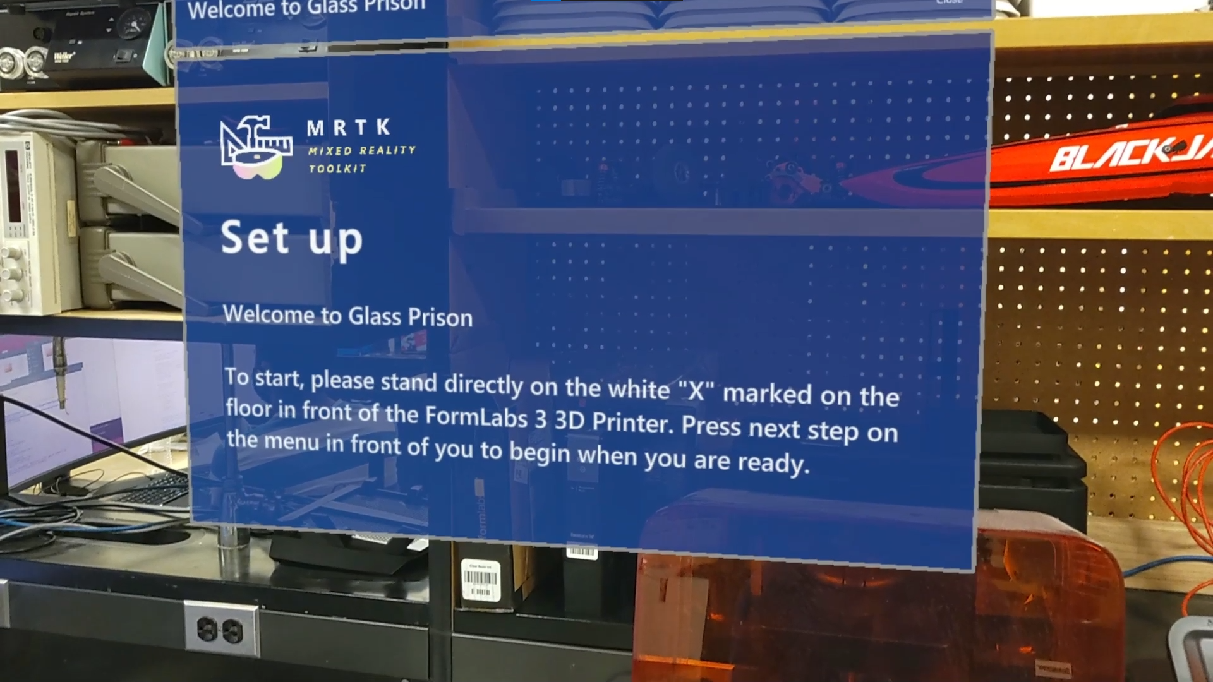

Figure 1: Application Start-Up

Due to the application not having a computer vision component to automatically center the world anchor to the 3D printer, the user is advised to stand on a marked section on the floor and to face the printer at the beginning and end of every step. Understanding that this is a tedious issue, we implemented a menu that follows the user around when they walk. This menu will always be automatically centered in front to their torso. If the user were to look and face in a different direction and press the next or previous stem buttons, the next scene will load directly in their line of sight. This becomes an issue if the holograms clip into the actual environment and the instructions can’t be read. This also takes away from the immersion of the application.

The image below shows an example of a step the user is completing by following the animation to the left of the actual 3D printer.

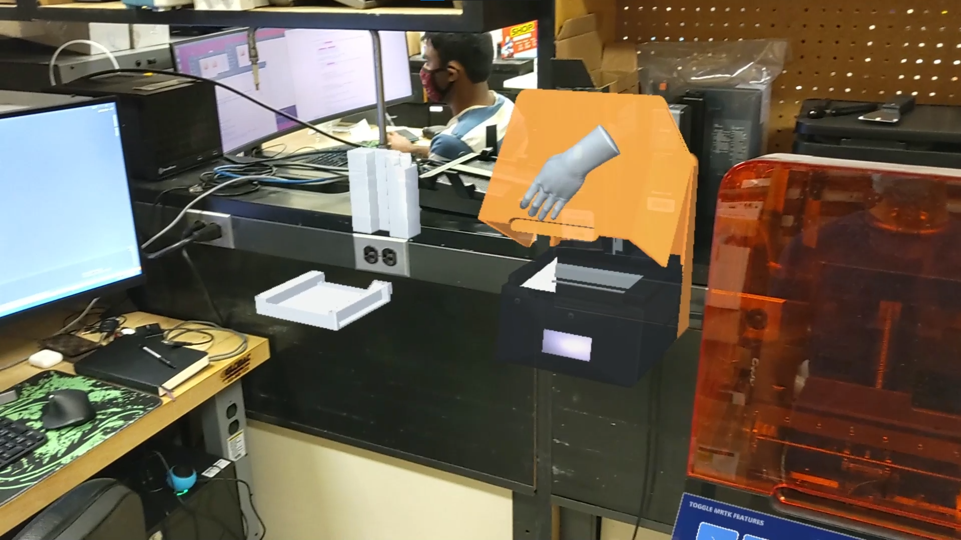

Figure 2: Lift Hood Animation

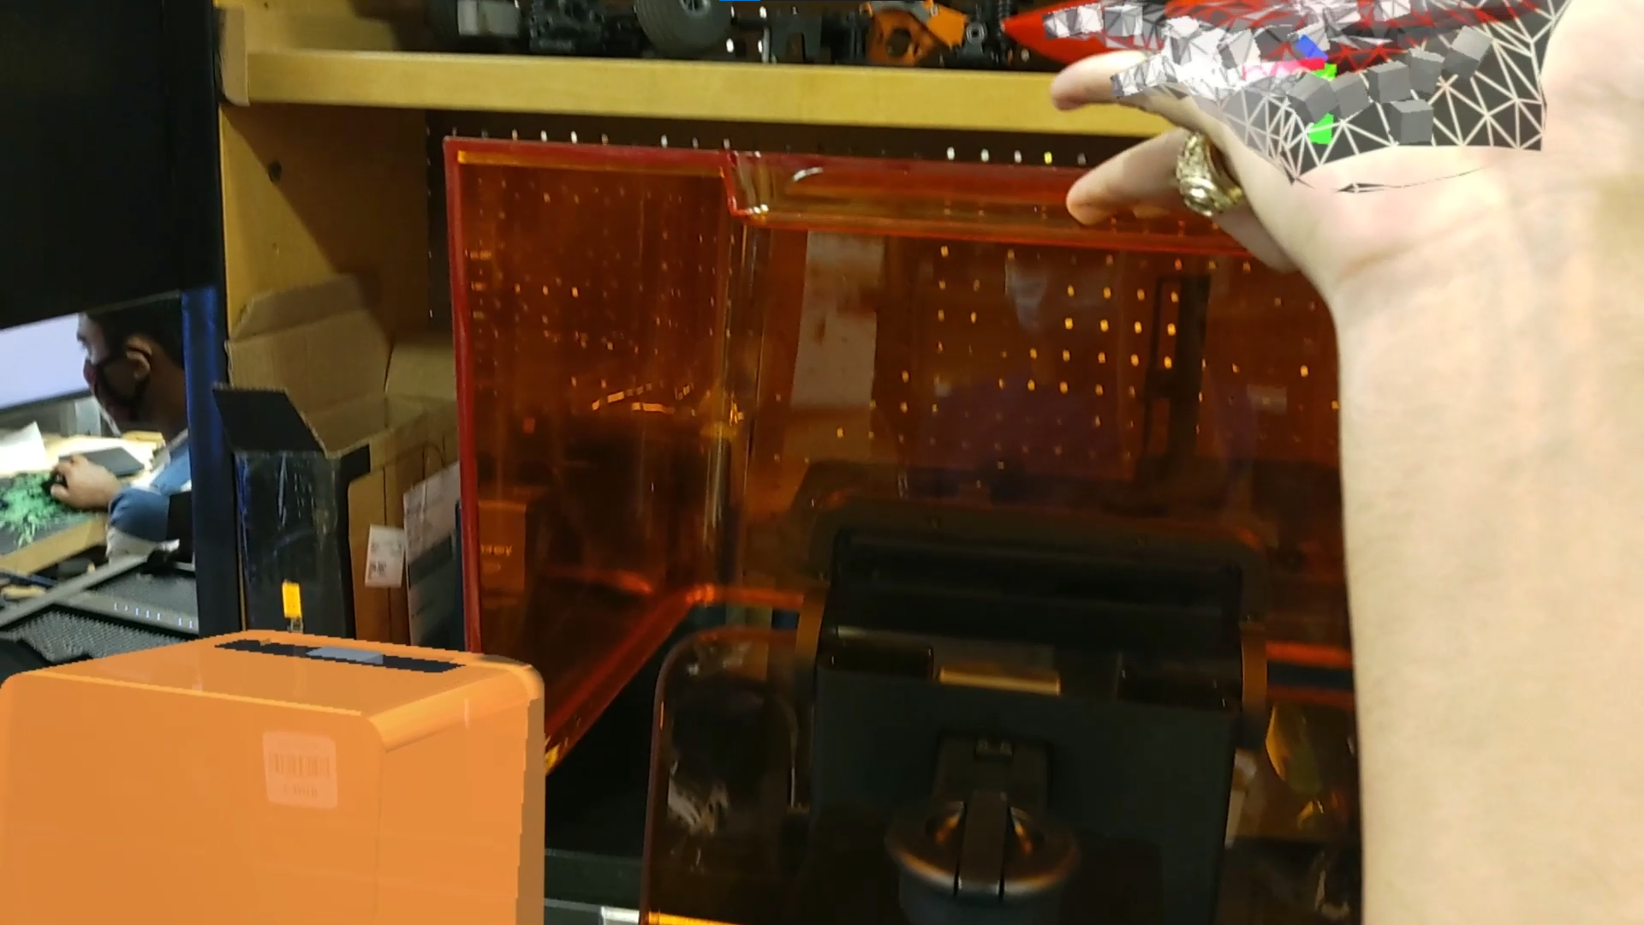

Figure 3: User Directly Lifting the Hood

Lastly, the final step of the application takes the user in an environment with the NLP log open in front of them. This log will allow the user to make minute and specific adjustments to the print settings right before the build initializes without having to even interact with the PreForm software. For example, the user was given a list of adjustments to make to the print, all the user has to do is read the list out loud and the Natural Language Processing subsystem will handle all the respective changes automatically and start the print. The image below shows the NLP log in the augmented reality environment.

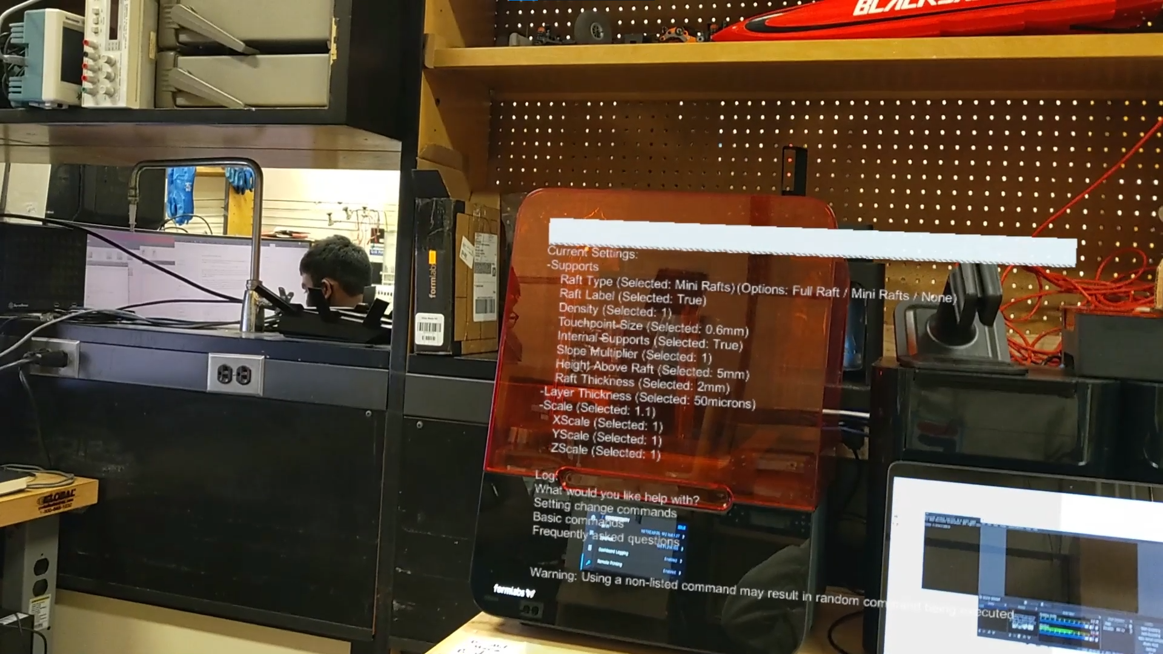

Figure 4: NLP Console Log

* 1. ***Conclusion***

In conclusion, the final build of the application is able to walk the user step by step through the entire process of setting up, adjusting, and initializing a print on the FormLabs Form 3 3D Printer. The first phase of the application walks the user through the setup of the printer by utilizing very detailed animations which depict the exact motions needed to complete each step of the setup. The second phase allows for an inexperienced user to directly change the print settings of a print without even needing to look at the PreForm software that is controlling the physical 3D printer. The application was tested by our sponsor, team members, and other researchers that happened to be in the lab during its development phase. Every single one of their criticisms were taken into account to further improve upon the clarity of the steps and the overall ease of use.

Unfortunately, the final build did not include the Computer Vision subsystem. Although the previously mentioned Vuforia Engine worked flawlessly in Unity through different webcams, the engine was not able to be initialized on the actual HoloLens 2 unit. Our sponsor advised us to leave the subsystem behind for him to handle himself. He will be using an open source tool called Stereokit. This tool allows a camera to track a QR code very efficiently. His plan is to place a QR code on the physical 3D printer and have the HoloLens track its position. To help him in this process, we have set up a World Anchor Centing script in every scene to make it easier to implement Stereokit in the final application.

1. **GitHub Link**

**-**<https://github.tamu.edu/omarquabili/Team-8-Senior-Design>